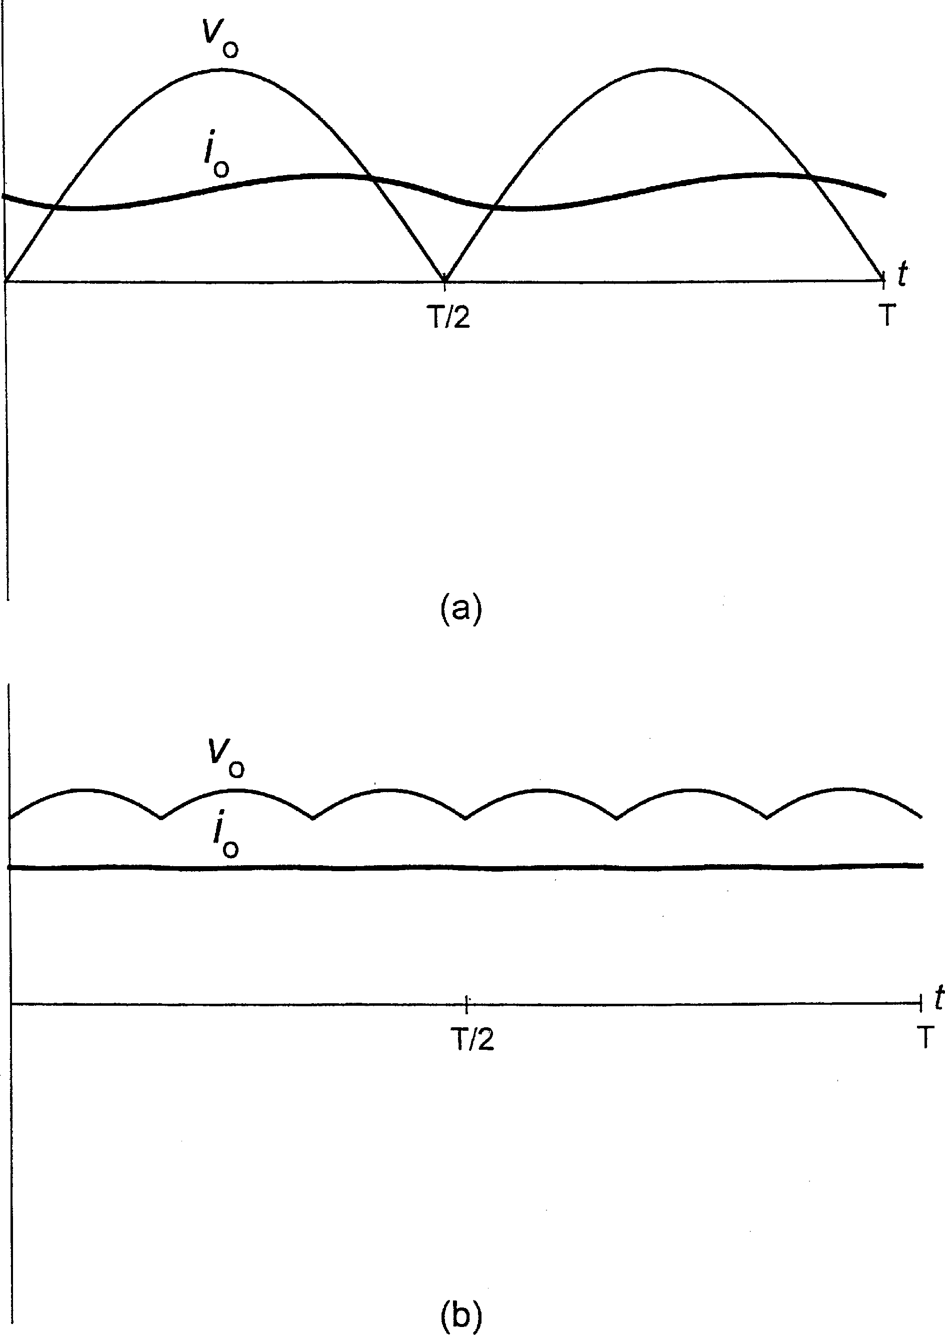

FIGURE 1.9

Output voltage and current waveforms in diode rectifiers: (a) single-phase bridge, (b) three-phase bridge.

There are two types of dual converters. Figure 1.16 shows the circulating current-free dual converter, that is, a rectifier in which single SCRs have been replaced with antiparallel SCR pairs. This arrangement is simple and compact, but it has two serious weaknesses. First, to prevent an interphase short circuit, only one internal rectifier can be active at a given time. For

example, with TB1 and TC10 conducting, TC20 is forward biased and, if fired, it would short lines B and C. This can easily be prevented by appropriate control of firing signals, but when a

change in polarity of the output current is required, the incoming rectifier must wait until the current in the outgoing rectifier dies out and the conducting SCRs turn off. This delay slows down the response to current control commands, which in certain applications is not acceptable. Secondly, as in all single phase-controlled rectifiers, if the firing angle is too large and=or the load inductance is too low, the output current becomes discontinuous, which is undesirable. For instance, such a current would generate a pulsating torque in a dc motor, causing strong acoustic noise and vibration.

In the circulating current-conducting dual converter, shown in Fig. 1.17, both constituent rectifiers are active simultaneously. Depending on the operating quadrant, one rectifier works with the firing angle, af;1, less than 90◦. The other rectifier operates in the inverter mode with the firing angle, af;2, given by

af;2 ¼ b — af;1 ð1:8Þ

where b is a controlled variable. It is maintained at a value of about 180◦, so that both rectifiers produce the same average voltage. However, the instantaneous output voltages of the rectifiers are not identical, and their difference generates a current circulating between the rectifiers. If the

rectifiers were directly connected as in Fig. 1.15b, the circulating current, limited by the resistance of wires and conducting SCRs only, would be excessive. Therefore, reactors are

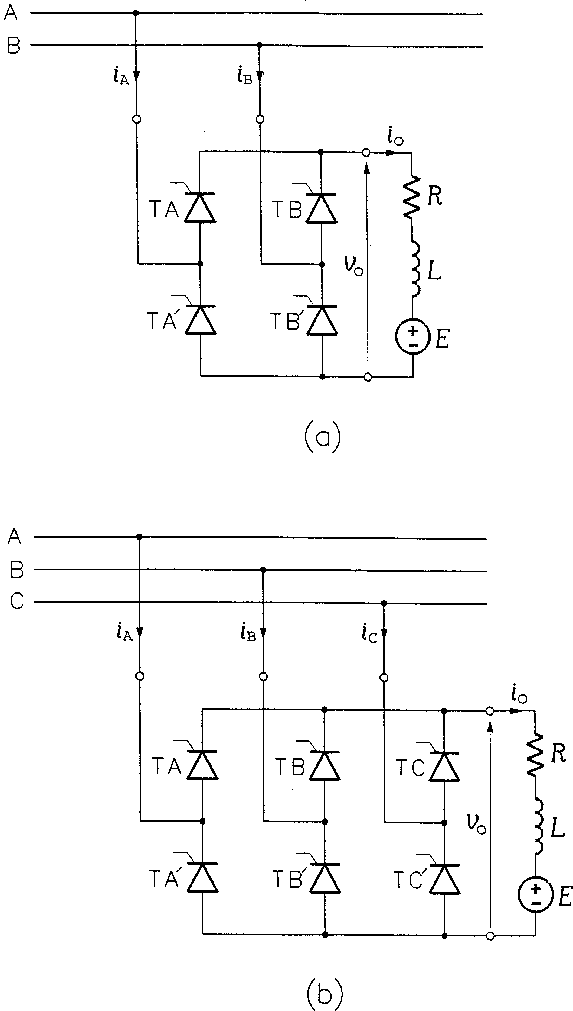

FIGURE 1.10

Phase-controlled rectifiers: (a) single-phase bridge, (b) three-phase bridge.

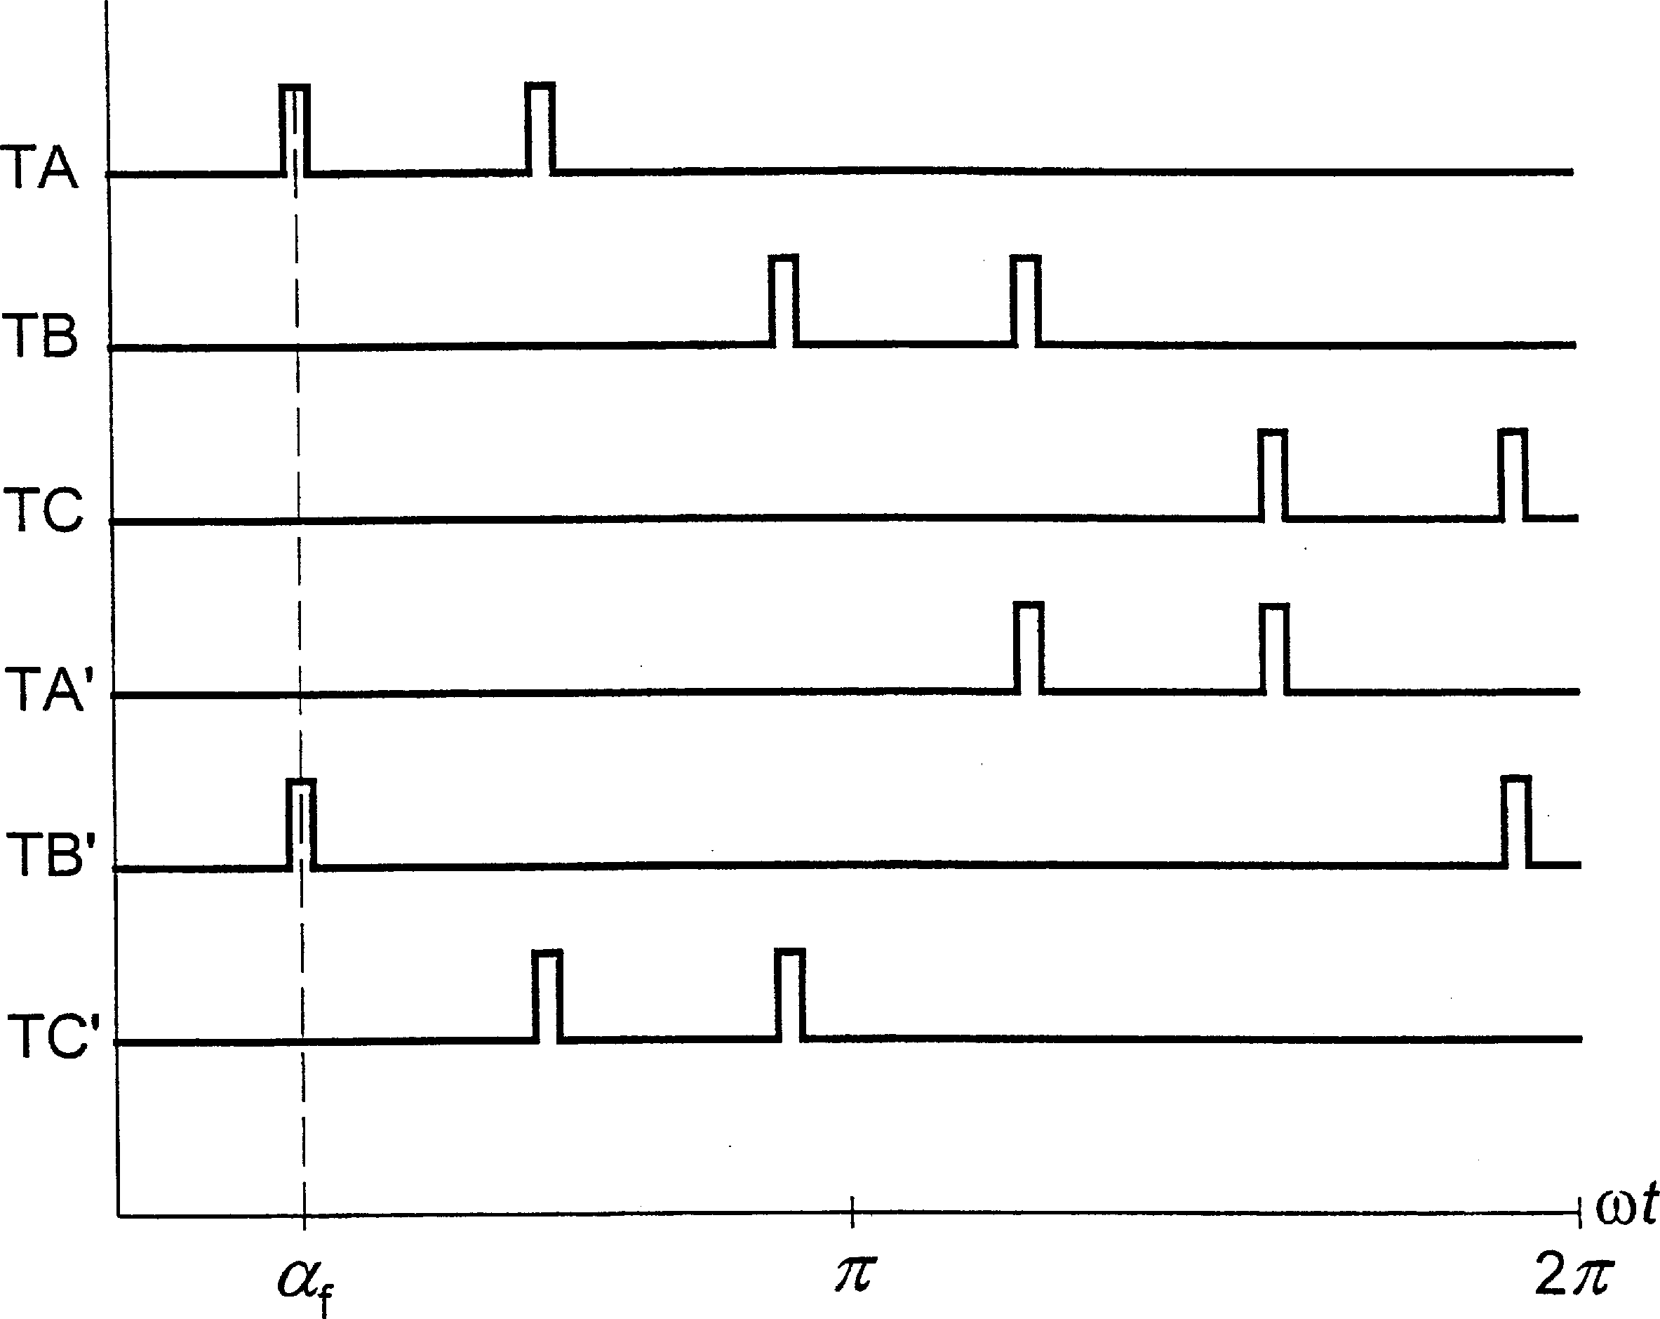

FIGURE 1.11

Firing pulses in the phase-controlled six-pulse rectifier.

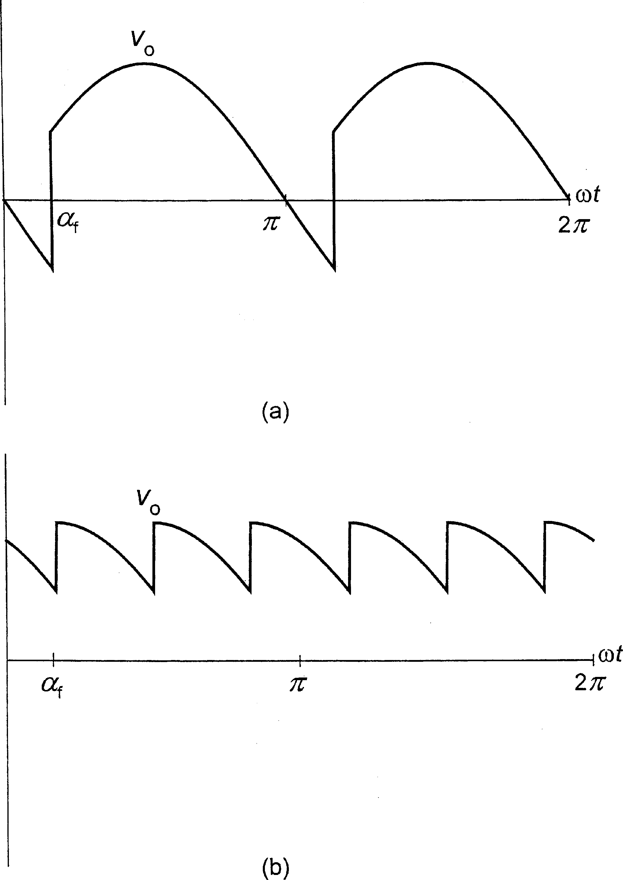

FIGURE 1.12

Output voltage waveforms in phase-controlled rectifiers: (a) single-phase bridge, (b) three-phase bridge (firing angle of 45◦).

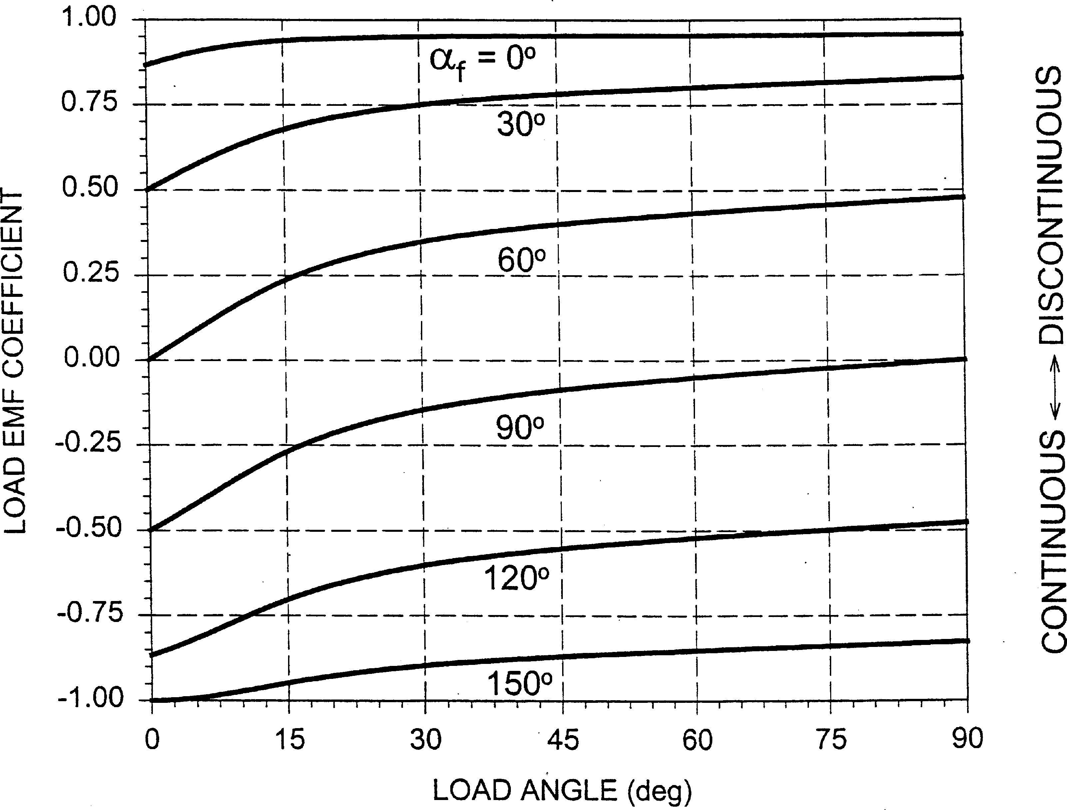

FIGURE 1.13

Diagram of conduction modes of a phase-controlled six-pulse rectifier.

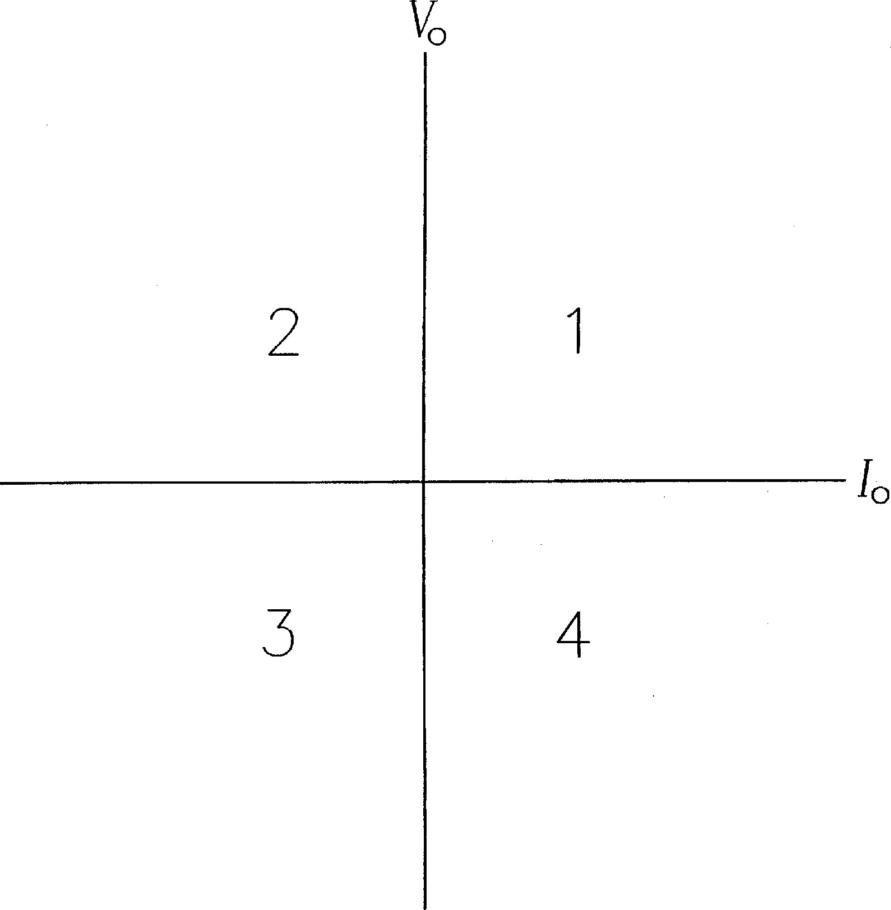

FIGURE 1.14

Operating quadrants of a controlled rectifier.

placed between the rectifiers and the load, strongly reducing the ac component of the circulating current.

The circulating current is controlled in a closed-loop control system which adjusts the angle b in Eq. (1.8). Typically, the circulating current is kept at the level of some 10% to 15% of the rated current to ensure continuous conduction of both constituent rectifiers. The converter is thus seen to employ a different scheme of operation from the circulating current-free converter. Even when the load consumes little power, a substantial amount of power enters one rectifier and the difference between this power and the load power is transferred back to the supply line by the second rectifier. Reactors L3 and L4 can be eliminated if the constituent rectifiers are supplied from isolated sources, such as two secondary windings of a transformer.

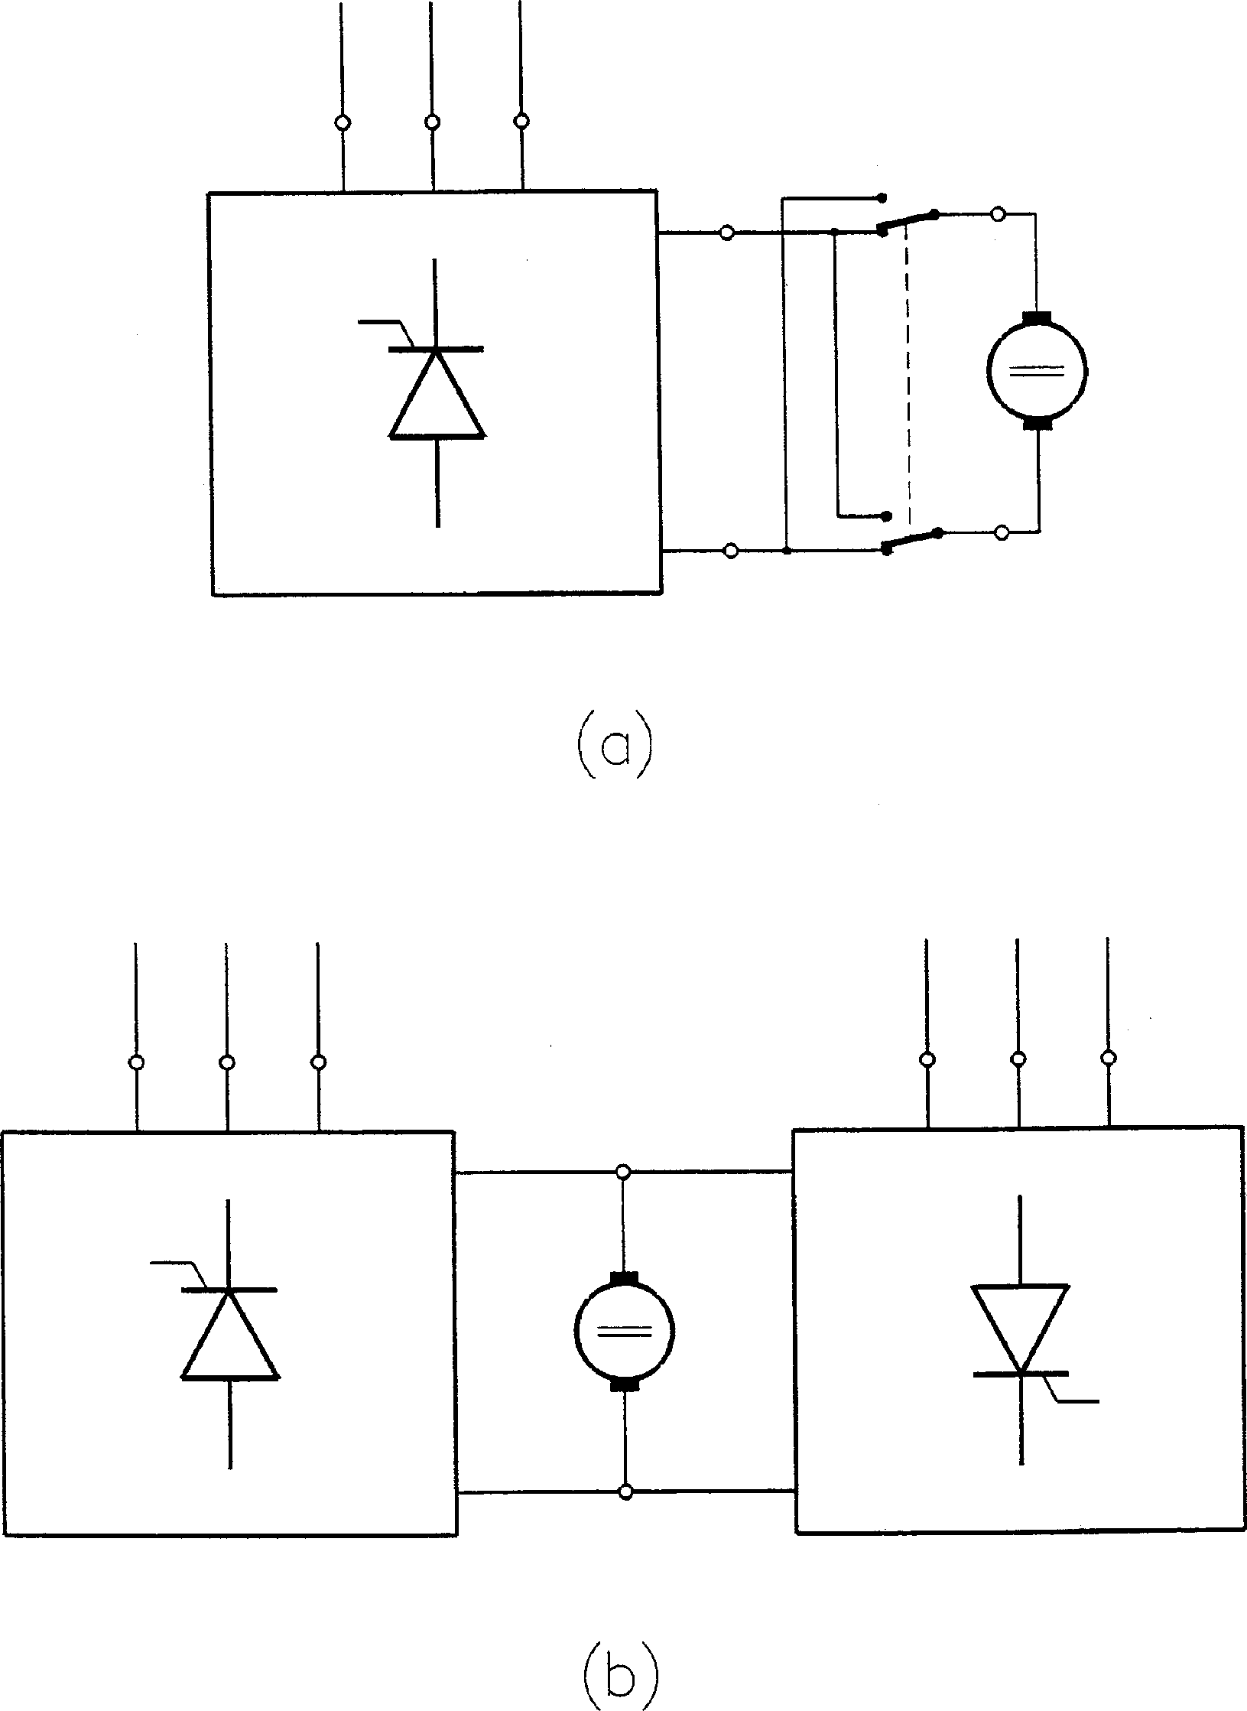

FIGURE 1.15

Rectifier arrangements for operation in all four quadrants: (a) rectifier with a cross-switch, (b) two rectifiers connected in antiparallel.

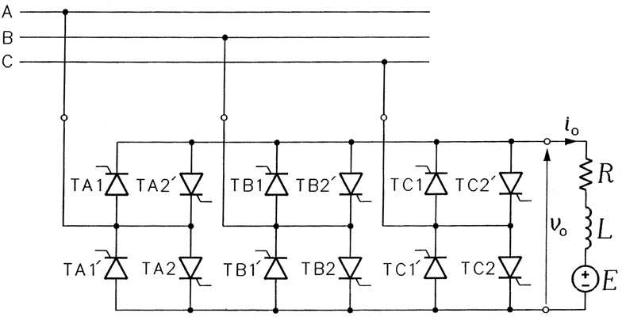

FIGURE 1.16

Circulating current-free dual converter.

Both the uncontrolled and phase-controlled rectifiers draw square-wave currents from the supply line. In addition, the input power factor is poor, especially in controlled rectifiers, where it is proportional to cos af . These flaws led to the development of PWM rectifiers, in which waveforms of the supply currents can be made sinusoidal (with certain ripple) and in phase with the supply voltages. Also, even with very low values of the magnitude control ratio, continuous output currents are maintained. Fully controlled semiconductor switches, typically IGBTs, are used in these rectifiers.

ð Þ

A voltage-source PWM rectifier based on IGBTs is shown in Fig. 1.18. The diodes connected in series with the IGBTs protect the transistors from reverse breakdown. Although the input current, ia, to the rectifier is pulsed, most of its ac component come from the input capacitors, while the current, iA, drawn from the power line is sinusoidal, with only some ripple. Appropriate control of rectifier switches allows obtaining a unity input power factor. Example waveforms of the output voltage, vo, output current, io, and input currents, ia and iA, are shown in Figs. 1.19 and 1.20, respectively.

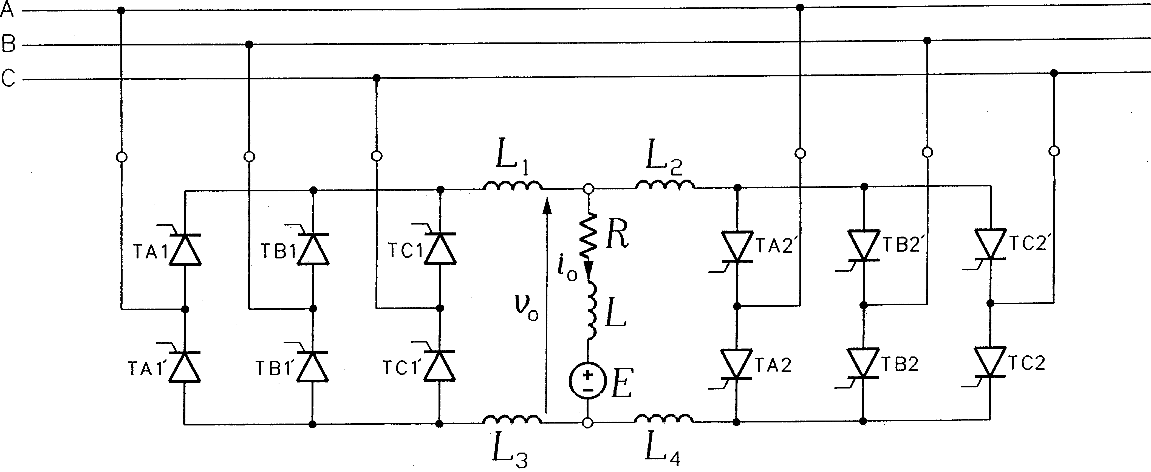

FIGURE 1.17

Circulating current-conducting dual converter.

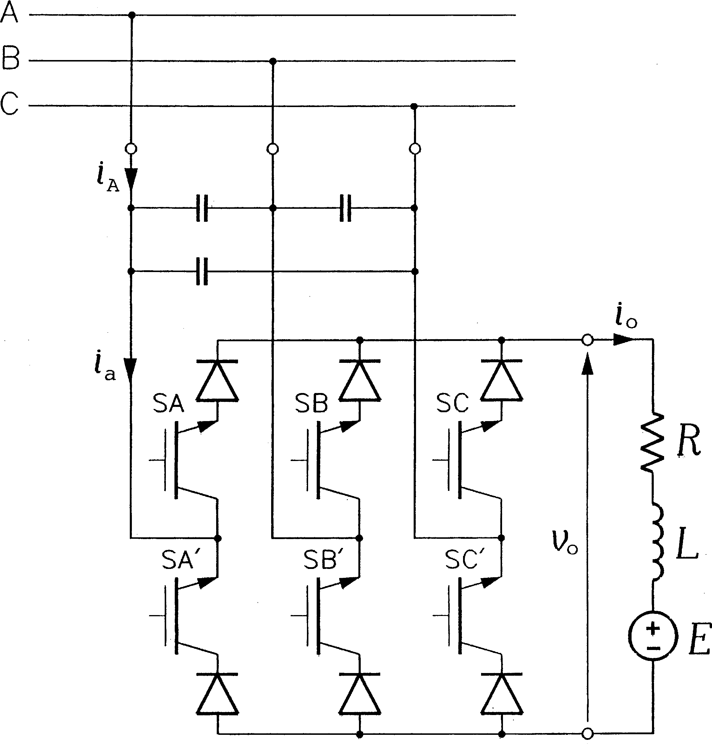

FIGURE 1.18

Voltage-source PWM rectifier.

The voltage-source PWM rectifier is a buck-type converter, that is, its maximum available output voltage (dependent on the PWM technique employed) is less than the peak input voltage. In contrast, the current-source PWM rectifier shown in Fig. 1.21 is a boost- type ac to dc converter, whose output voltage is higher than the peak input voltage. Figure 1.22 depicts example waveforms of the output voltage and current and the input current of the rectifier.

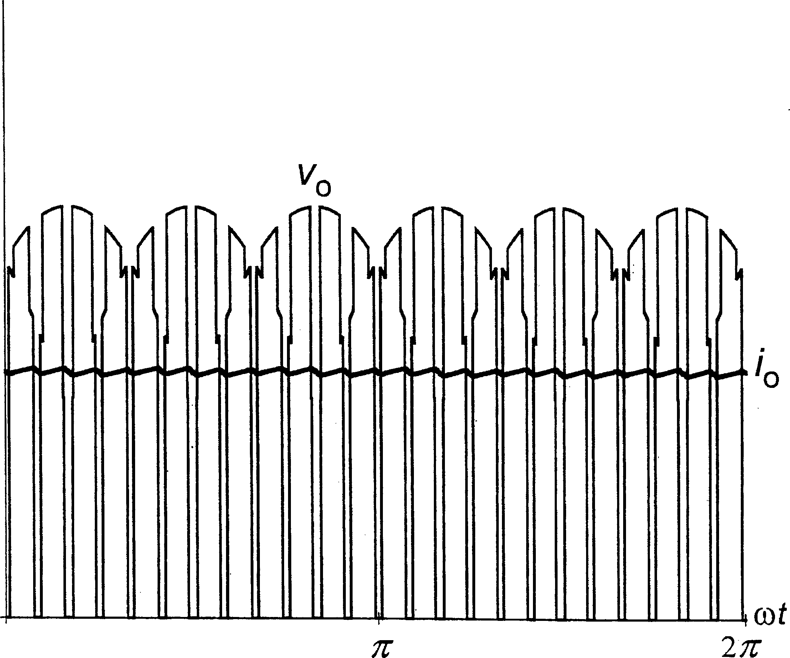

FIGURE 1.19

Output voltage and current waveforms in a voltage-source PWM rectifier.

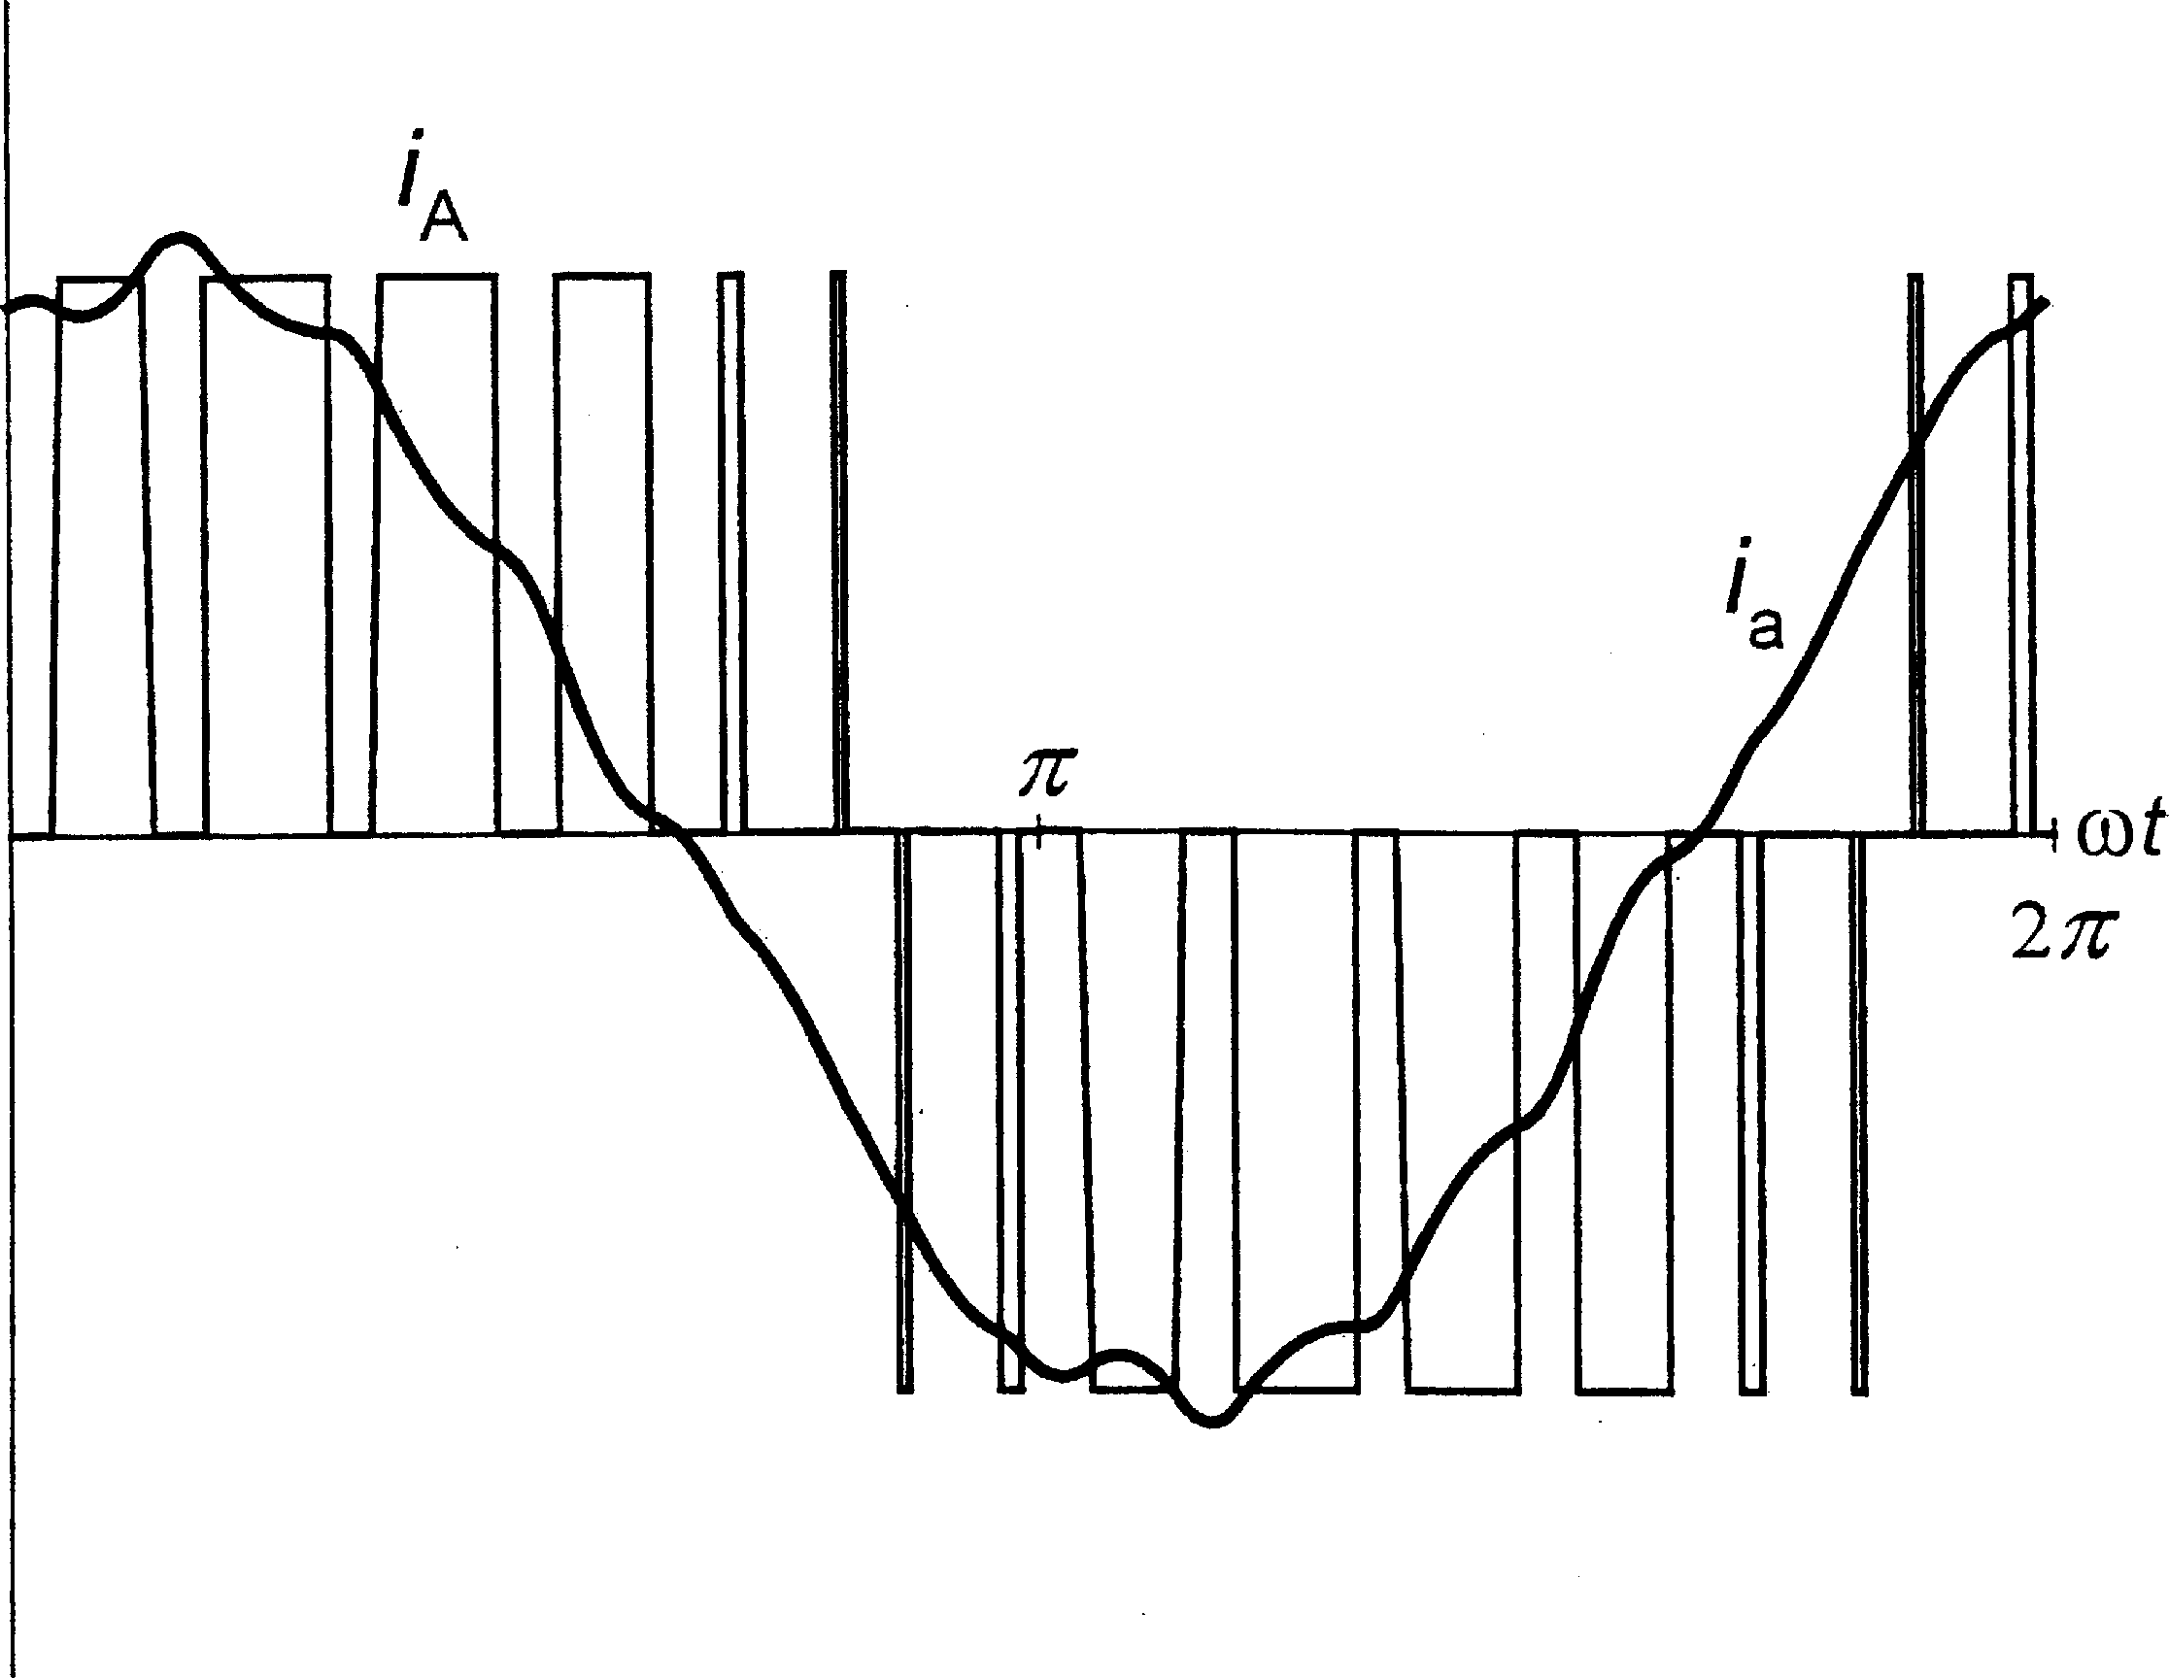

FIGURE 1.20

Input current waveforms in a voltage-source PWM rectifier.

The amount of ripple in the input and output currents of the PWM rectifiers described depends on the switching frequency and size of the inductive and capacitive components involved. In practice, PWM rectifiers are typically of low and medium power ratings.

AC TO AC CONVERTERS

There are three basic types of ac to dc converters. The simplest ones, the ac voltage controllers, allow controlling the output voltage only, while the output frequency is the same as the input frequency. In cycloconverters, the output frequency can be controlled, but it is at least one order of magnitude lower than the input frequency. In both the ac voltage controllers and cycloconverters, the maximum available output voltage approaches the input voltage. Matrix

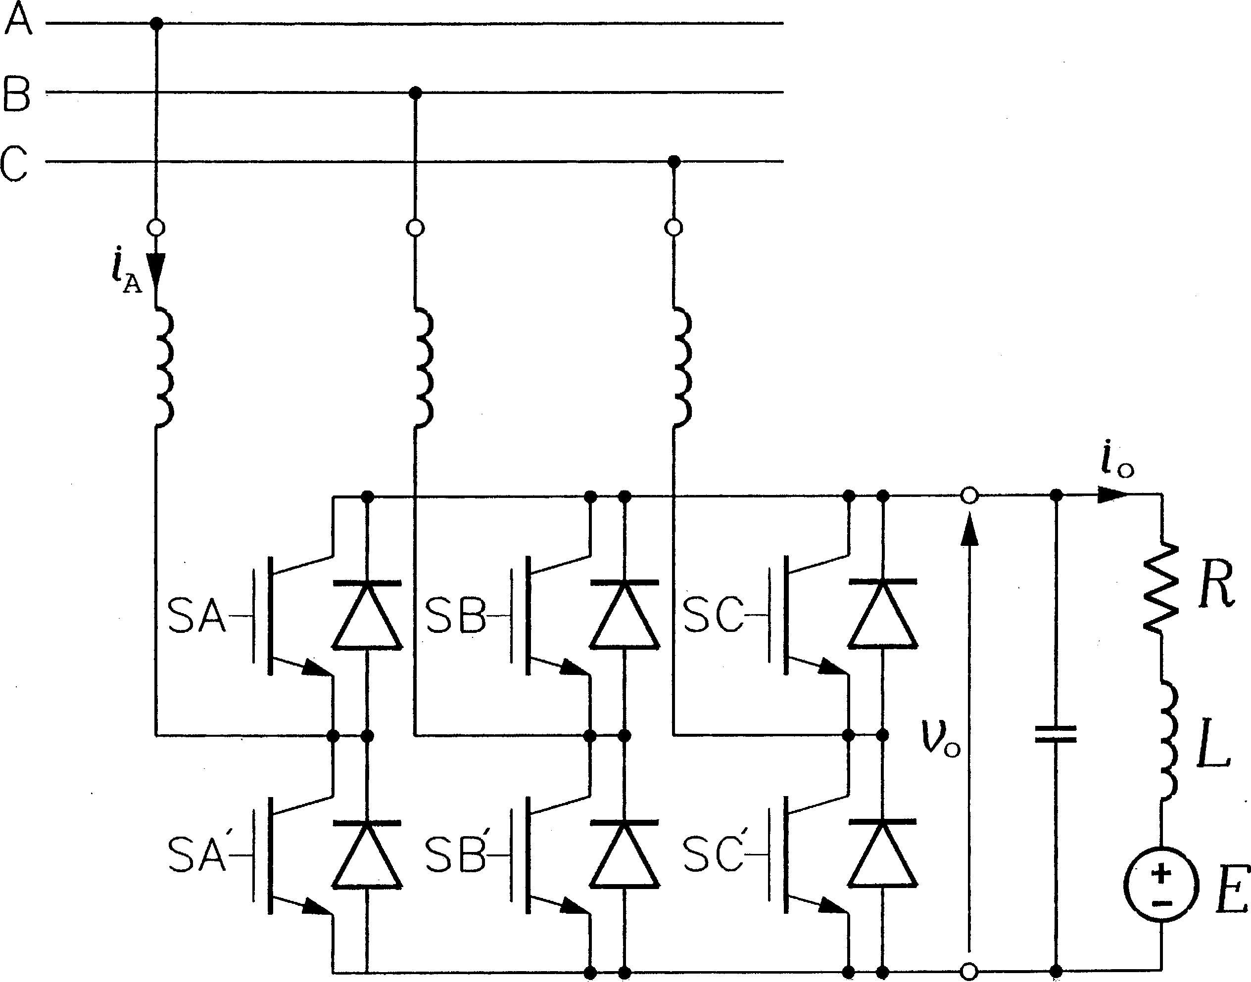

FIGURE 1.21

Current-source PWM rectifier.

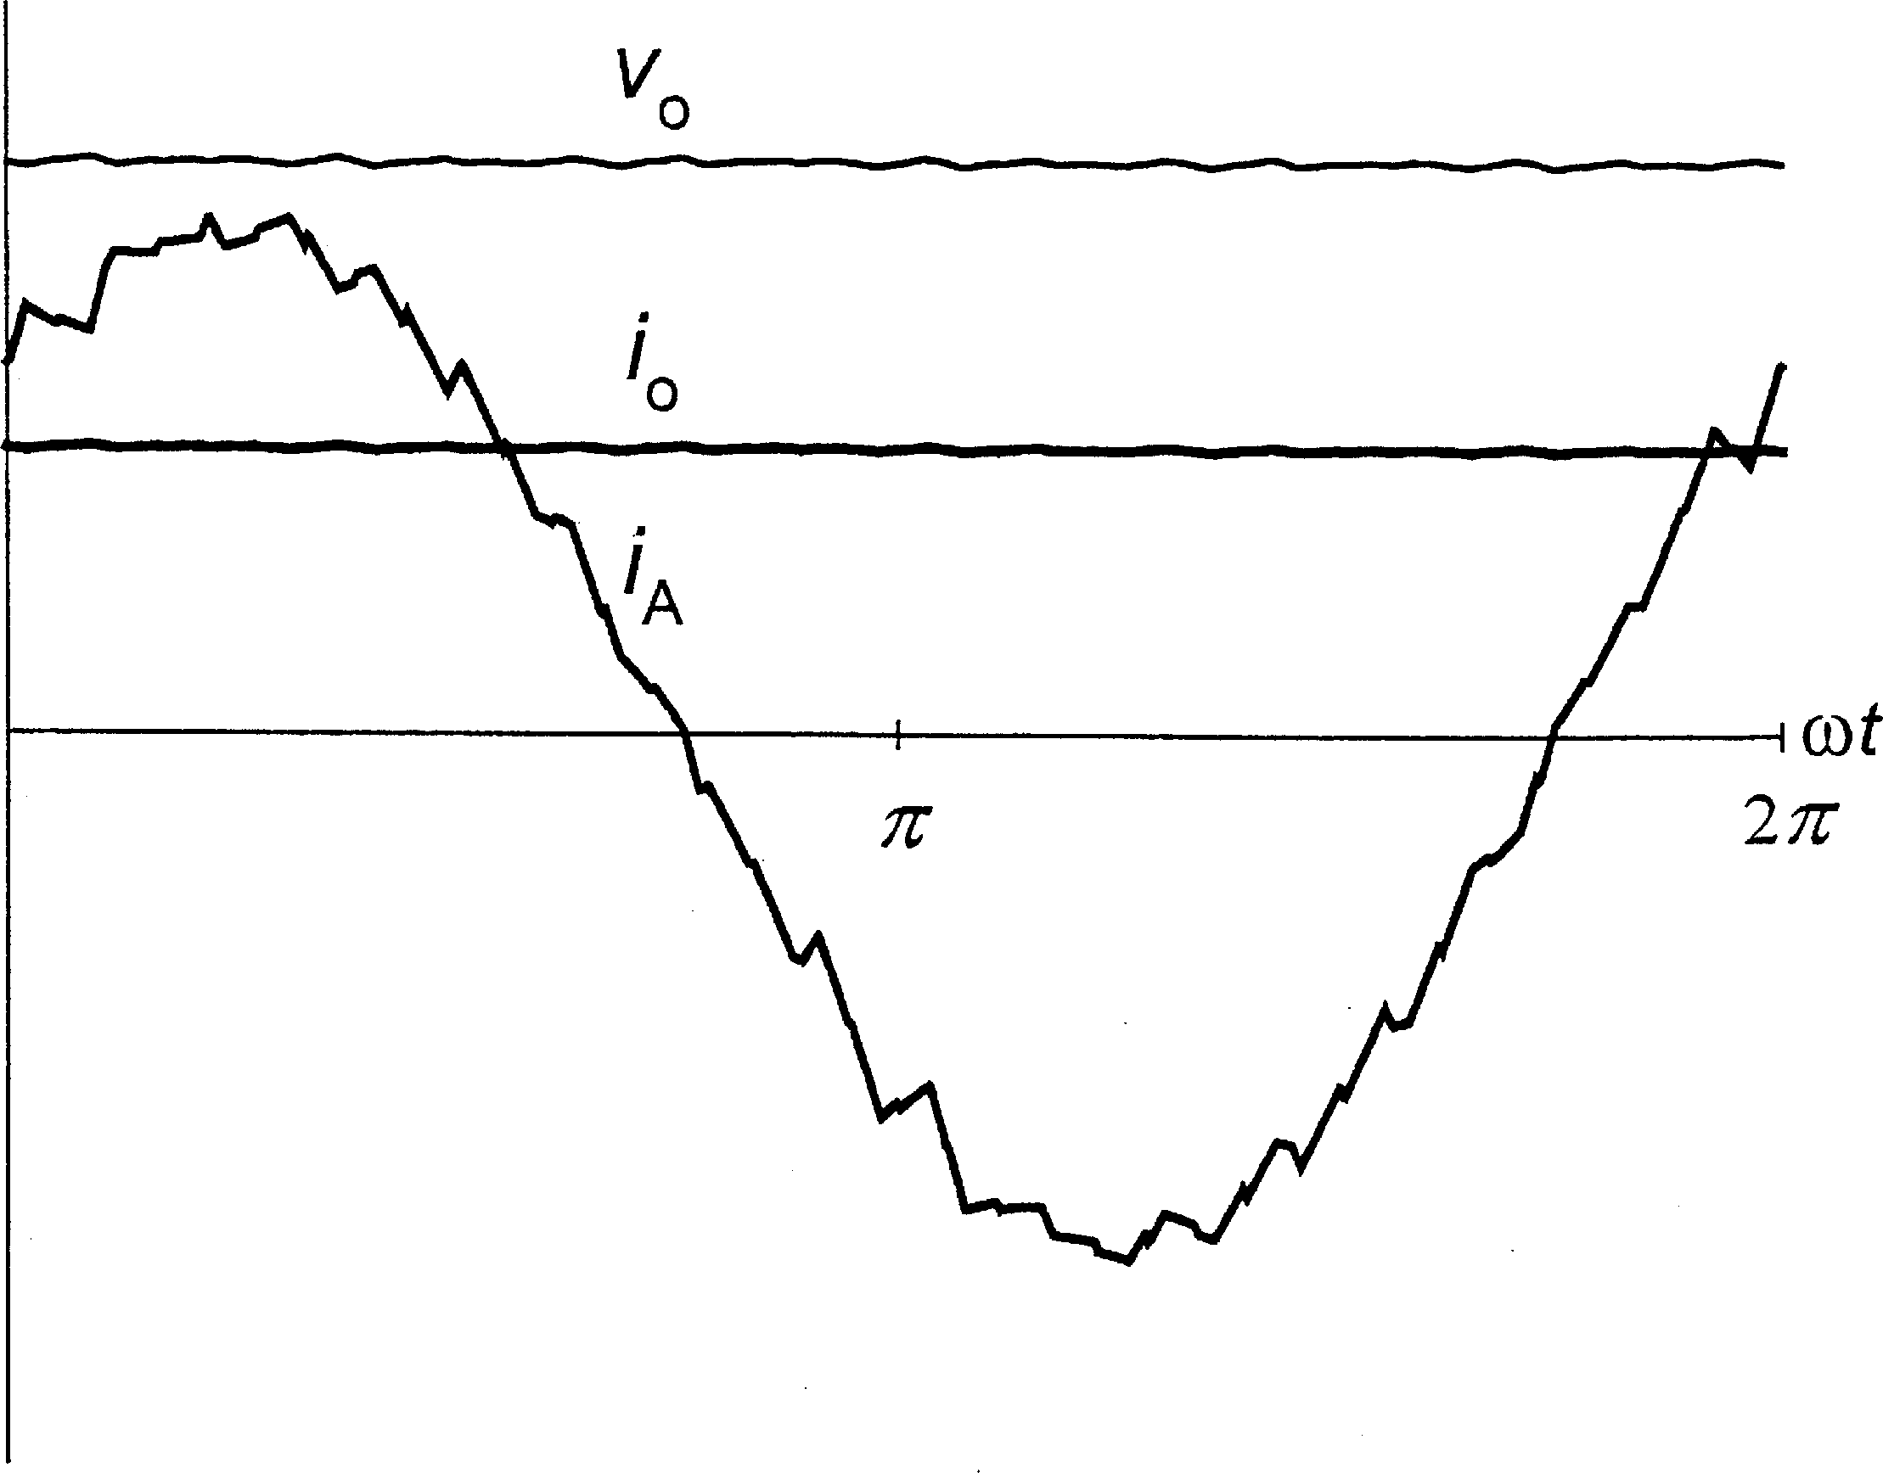

FIGURE 1.22

Waveforms of the output voltage and current and the input current in a current-source PWM rectifier.

converters are most versatile, with no inherent limits on the output frequency, but the maximum available output voltage is about 15% lower than the input voltage.

A pair of semiconductor power switches connected in antiparallel constitutes the basic building block of ac voltage controllers. Phase-controlled converters employ pairs of SCRs, SCR-diode pairs, or triacs. A single-phase ac voltage controller is shown in Fig. 1.23 and

example waveforms of the output voltage and current in Fig. 1.24. The rms output voltage, Vo, is given by

**ﬃﬃﬃﬃﬃﬃﬃﬃﬃﬃﬃﬃﬃﬃﬃﬃﬃﬃﬃ ﬃﬃﬃ**

**1 1**

**Vo ¼ Vi**

**ð1:9Þ**

where ae denotes the so-called extinction angle, dependent on the firing angle, af , and load angle, j. The precise value of j is usually unknown and changing. Consequently, as shown in Fig. 1.25, only an envelope of control characteristics, M f af , where M Vo=Vi, can accurately be determined.

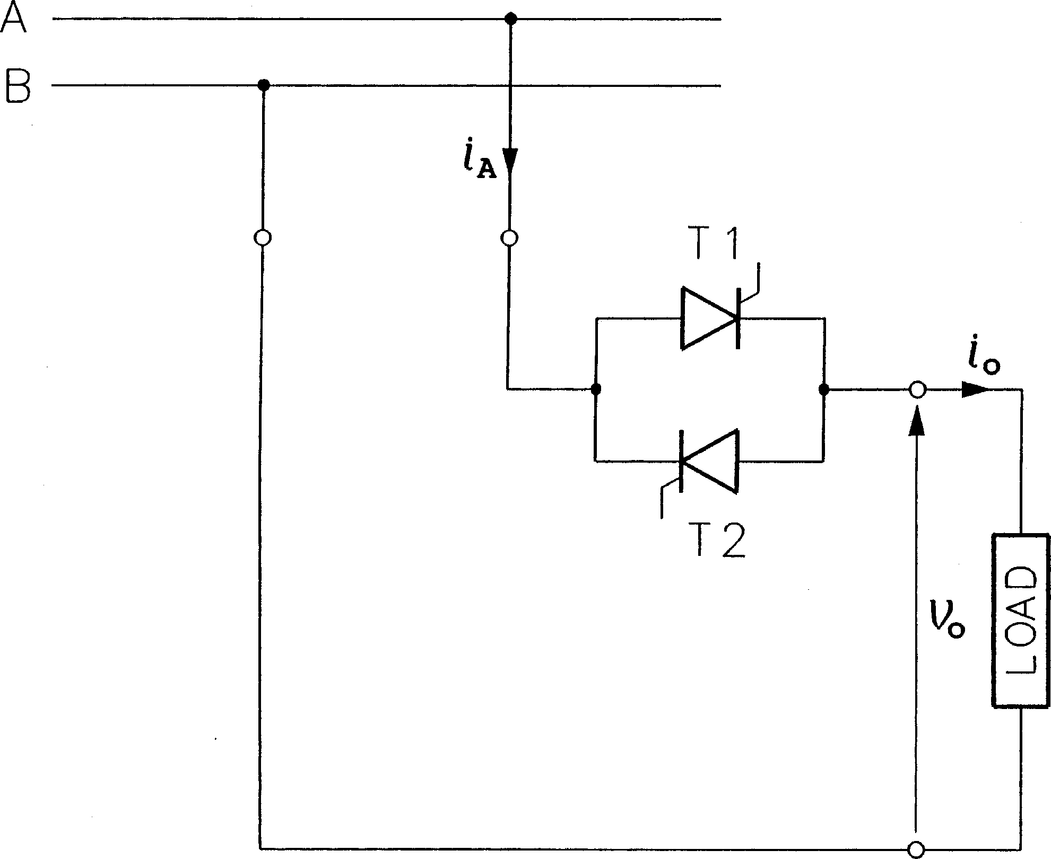

FIGURE 1.23

Phase-controlled single-phase ac voltage controller.

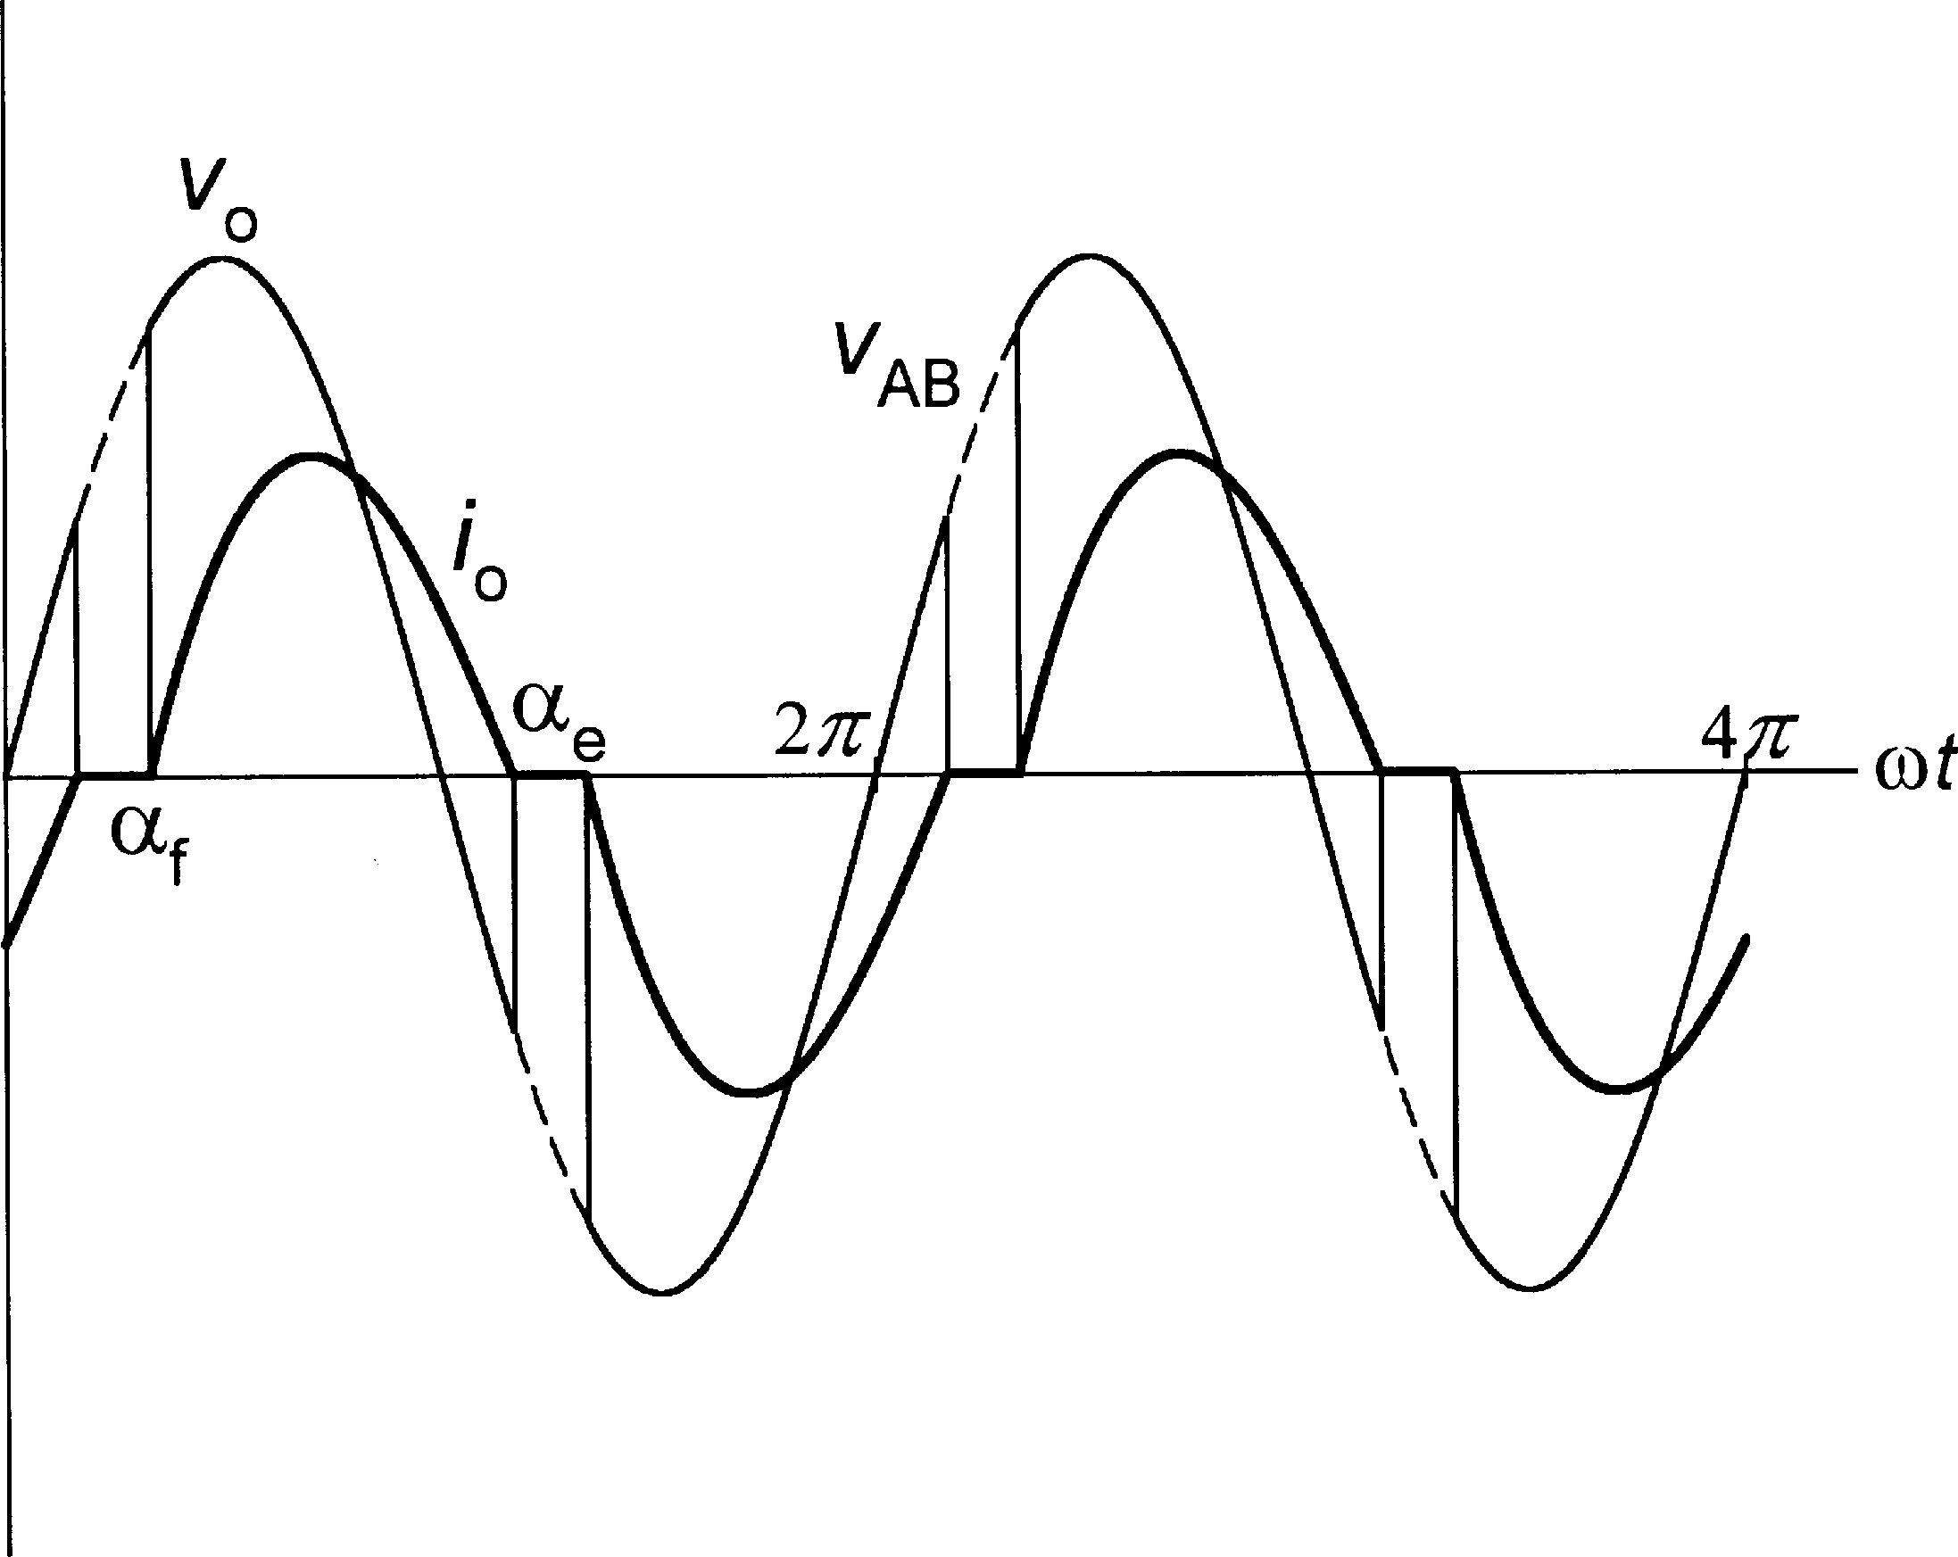

FIGURE 1.24

Output voltage and current waveforms in a phase-controlled single-phase ac voltage controller (firing angle of 60◦).

The output voltage equals the input voltage, and the current is continuous and sinusoidal, when af j. This can easily be done by applying a packet of narrowly spaced firing pulses to a given switch at the instant of zero-crossing of the input voltage waveform. The first pulse which

¼

manages to fire the switch appears at ot j, and the ac voltage controller becomes a static ac switch, which can be turned off by cancelling the firing pulses.

≈

Several topologies of phase-controlled three-phase ac voltage controllers are feasible, of which the most common, fully controlled controller, usually based on triacs, is shown in Fig. 1.26.

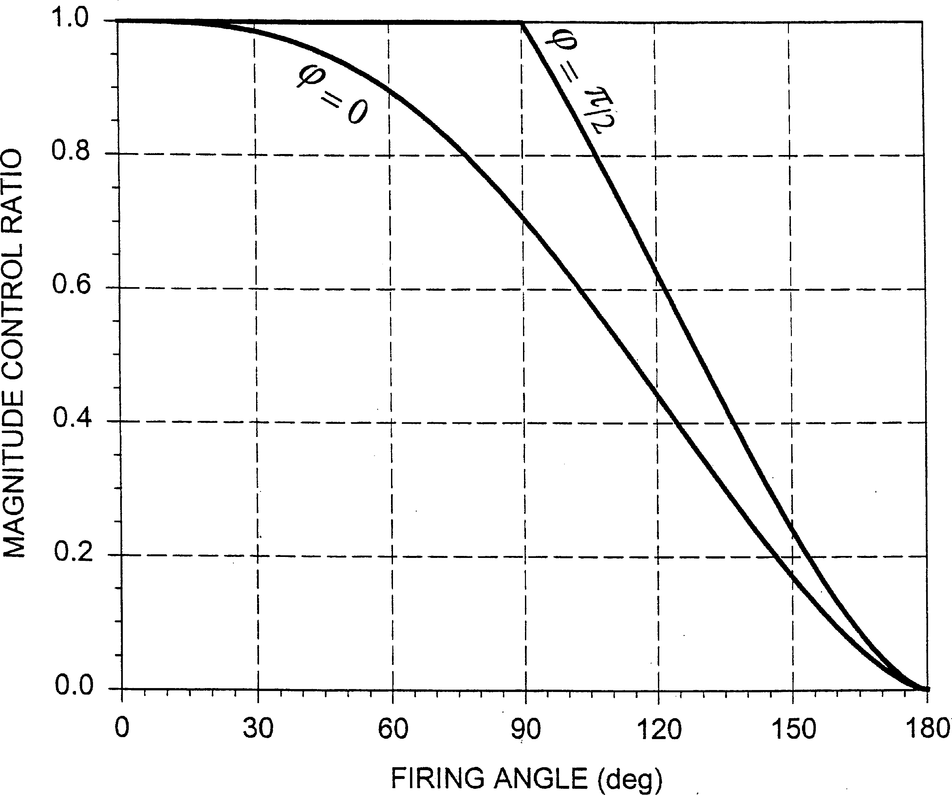

FIGURE 1.25

Envelope of control characteristics of a phase-controlled single phase ac voltage controller.

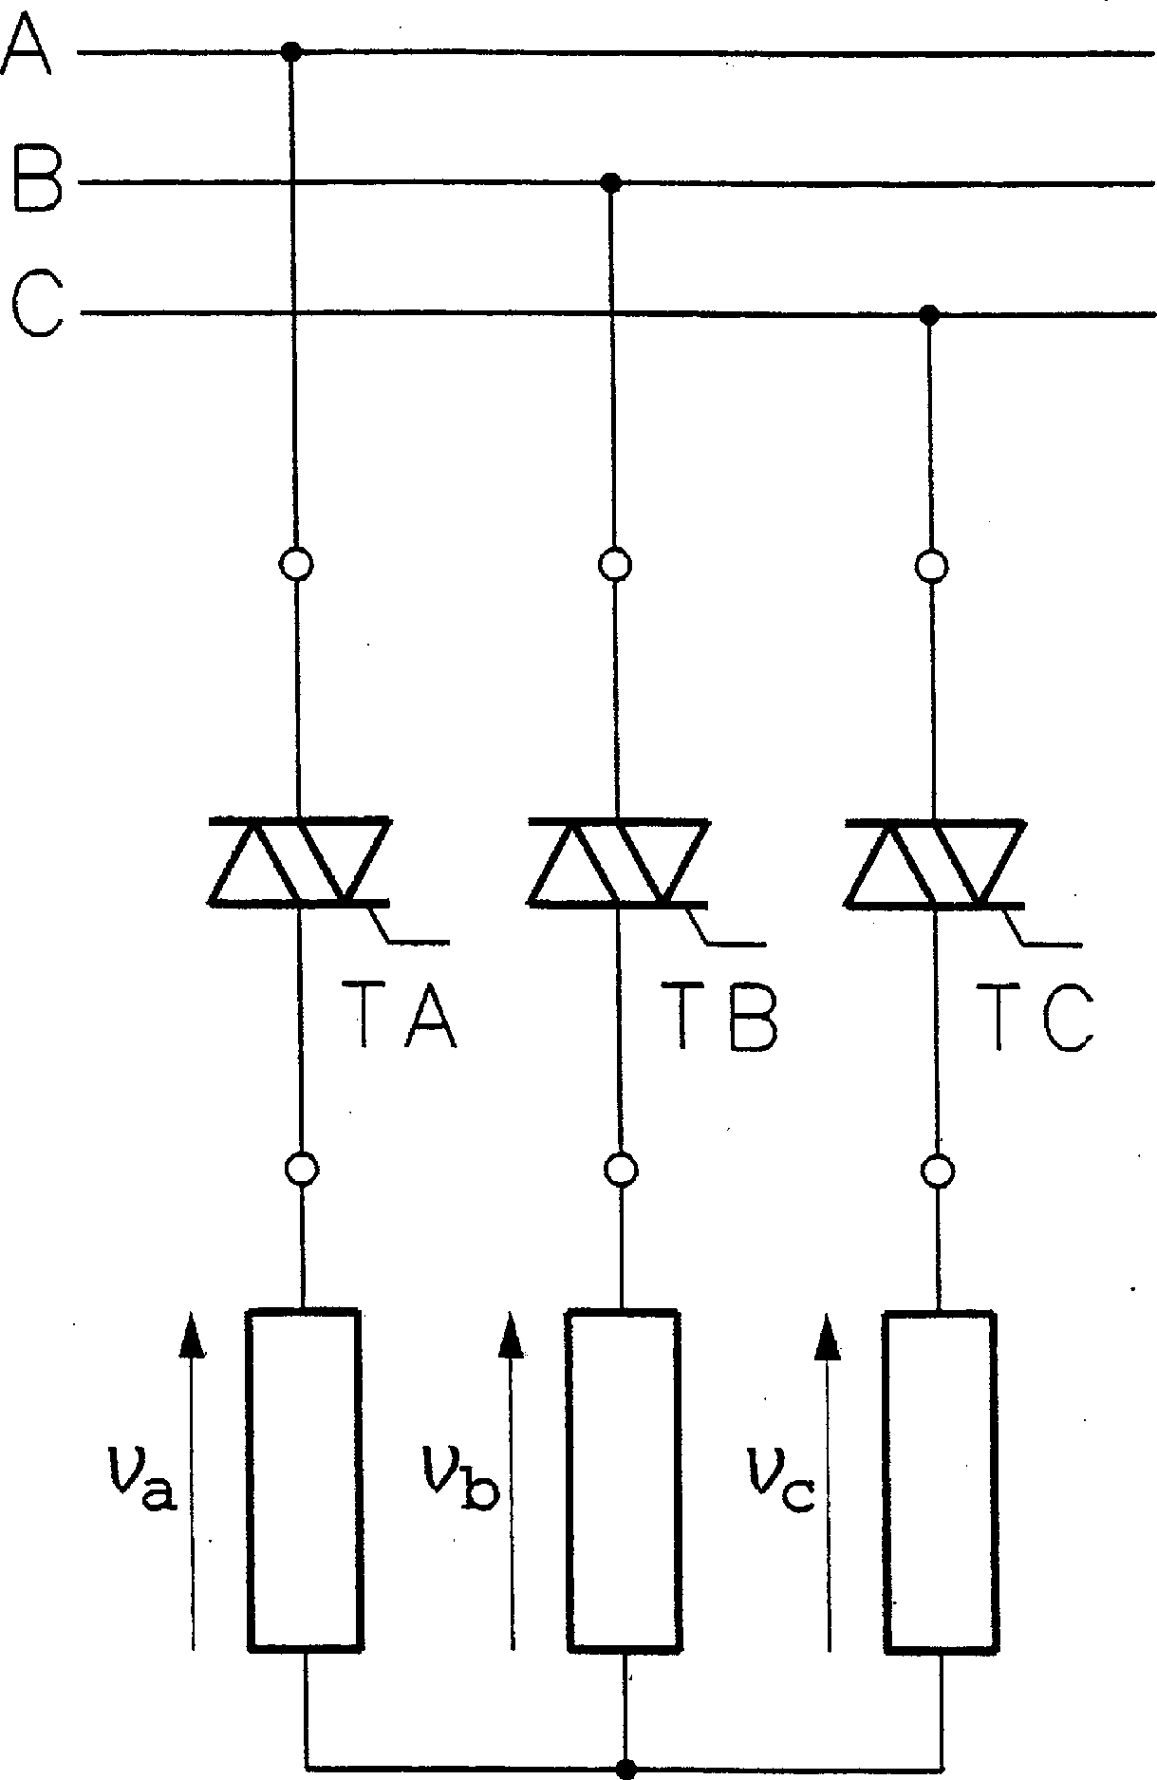

FIGURE 1.26

Phase-controlled, fully controlled three-phase ac voltage controller.

If switching functions, a, b, and c, are assigned to each triac, output voltages, va; vb, and vc, of the controller are given by

2 v 3

a

2 32 3

a —b c vA

where vA; vB, and vC are line-to-ground voltages of the supply line. Analysis of operation of the fully controlled controller is rather difficult since, depending on the load and firing angle, the controller operates in one of three modes: (1) Mode 1, with two or three triacs conducting; (2) Mode 2, with two triacs conducting; and (3) Mode 3, with none or two triacs conducting. The

output voltage waveforms are complicated, as illustrated in Fig. 1.27 for voltage va of a controller with resistive load and a firing angle of 30◦. The waveform consists of segments of the vA; vAB=2, and vAC=2 voltages. The envelope of control characteristics of the controller is shown in Fig. 1.28.

Four other topologies of the phase-controlled three-phase ac voltage controller are shown in Fig. 1.29. If ratings of available triacs are too low, actual SCRs must be used. In that case, an SCR-diode pair is employed in each phase of the controller. Such a half-controlled controller is shown in Fig. 1.29a. If the load is connected in delta, the three-phase ac voltage controller can have the topology shown in Fig. 1.29b. The triacs (or SCR–diode pairs) can also be connected after the load, as in Figs. 1.29c and 1.29d.

Similarly to phase-controlled rectifiers, phase-controlled ac voltage controllers draw distorted currents from the supply line, and their input power factor is poor. Again, as in the rectifiers, these characteristics can significantly be improved by employing pulse width modulation. Pulse width modulated ac voltage controllers, commonly called ac choppers, require fully controlled power switches capable of conducting current in both directions. Such switches can be assembled from transistors and diodes; two such arrangements are shown in Fig. 1.30.

The PWM ac voltage controller, also known as ac chopper, is shown in Fig. 1.31 in the single-phase version. For simplicity, and to stress the functional analogy to the generic converter, the bidirectional switches are depicted as mechanical contacts. When the main switch, S1, is

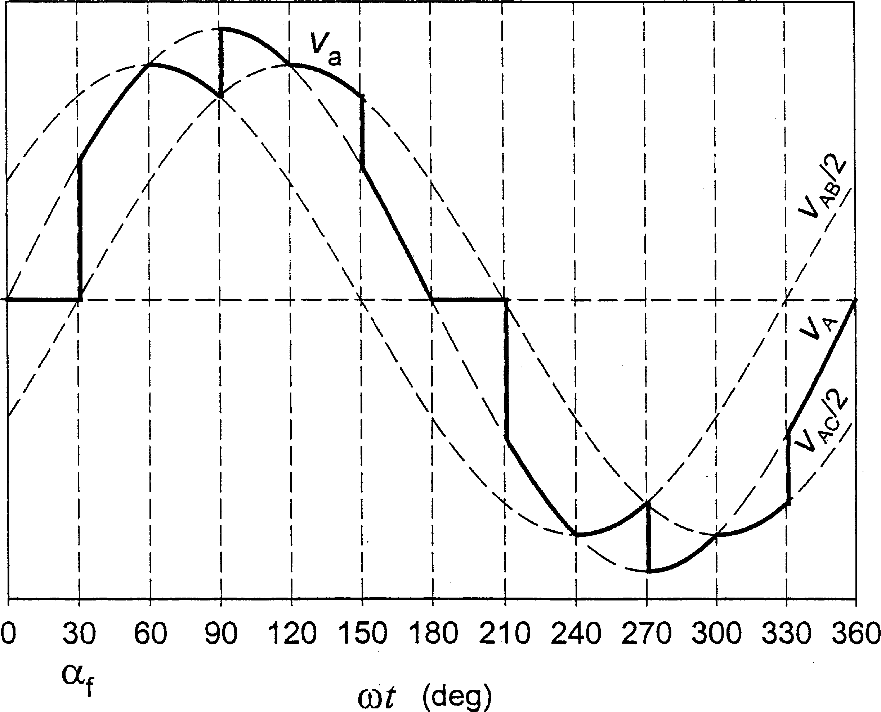

FIGURE 1.27

Waveform of the output voltage in a fully controlled three-phase ac voltage controller (resistive load, firing angle of 30◦).

chopping, that is, turning on and off many times per cycle, the current drawn from the LC input filter is interrupted. Therefore, another switch, S2, is connected across the load. It plays the role of the freewheeling switch S0 in the generic power converter in Fig. 1.1. Switches S1 and S2 are operated complementarily: when S1 is turned on, S2 is turned off and vice versa. Denoting the

duty ratio of switch S1 by D1, the magnitudepcﬃoﬃﬃﬃntrol ratio, M, taken as ratio of the rms output

voltage, Vo, to rms input voltage, Vi, equals D1.

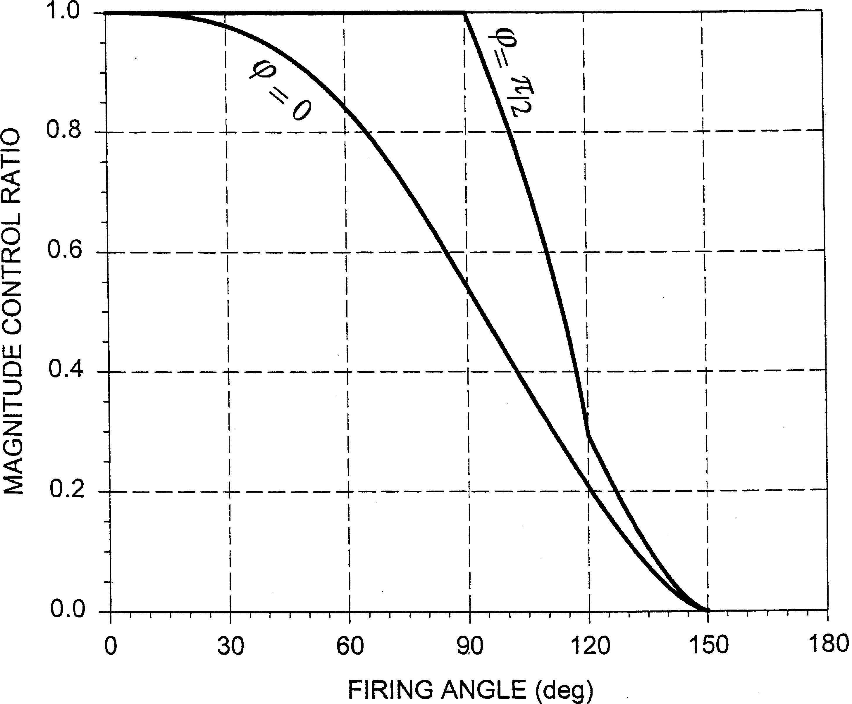

FIGURE 1.28

Envelope of control characteristics of the fully controlled three-phase ac voltage controller.

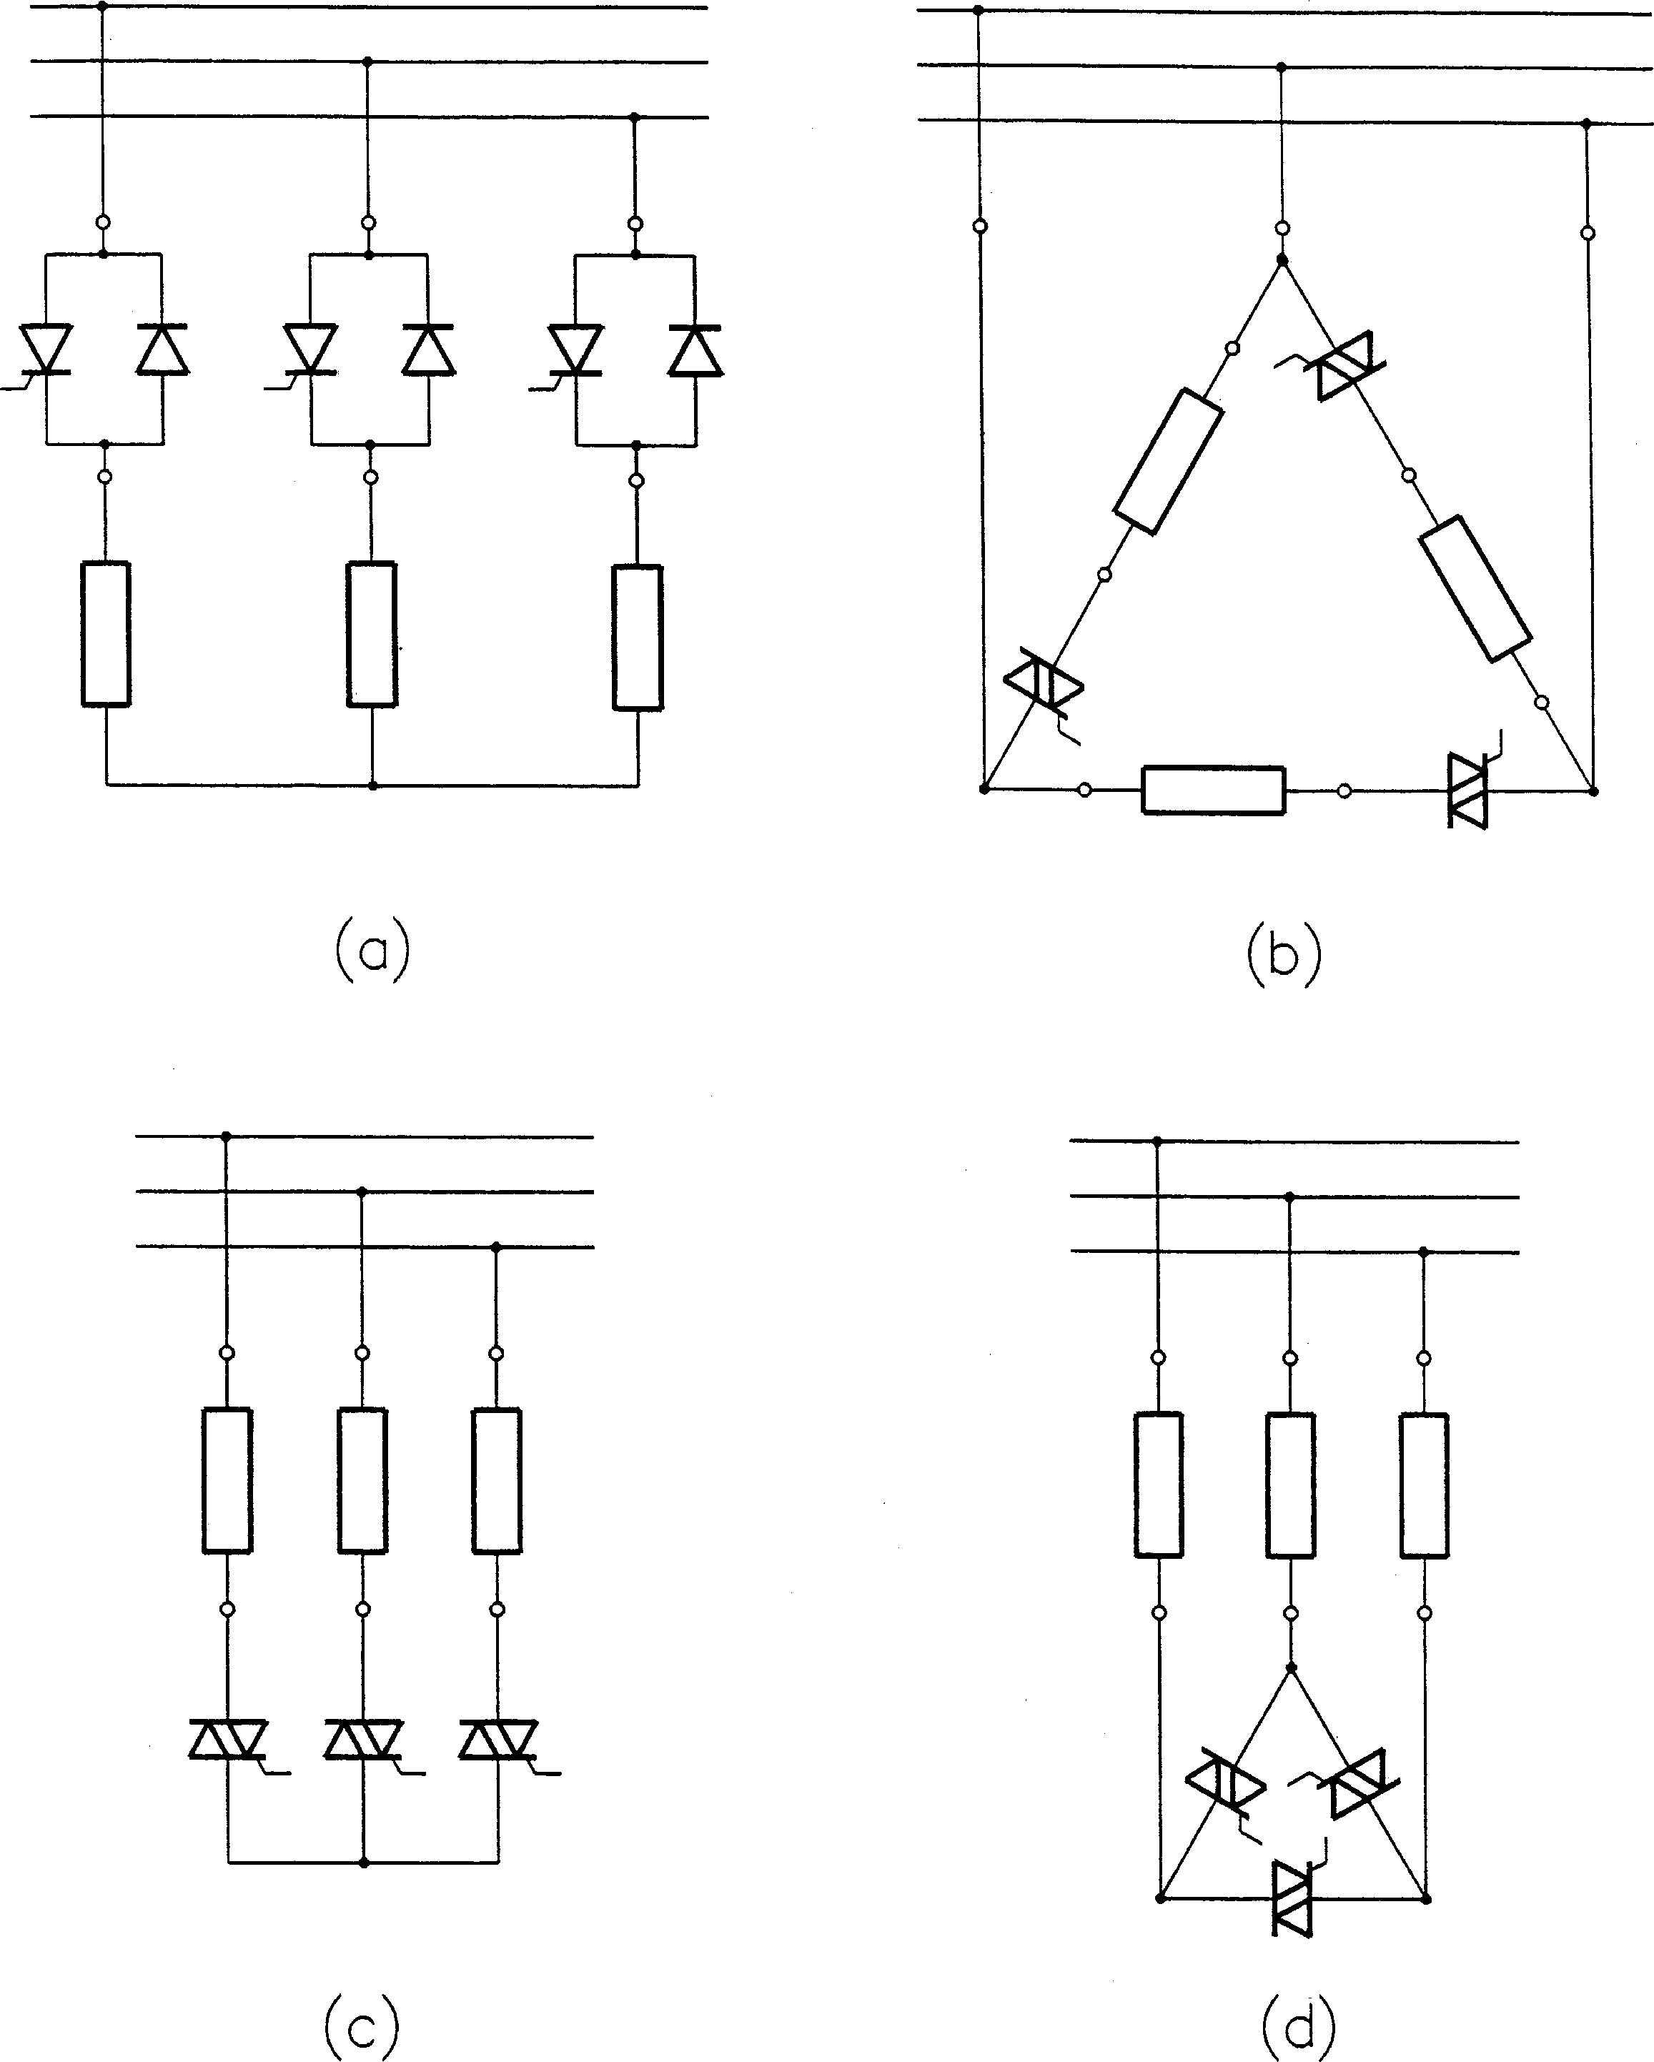

FIGURE 1.29

Various topologies of phase-controlled three-phase ac voltage controllers: (a) half-controlled, before-load,

(b) delta-connected, before-load, (c) wye-connected after-load, (d) delta-connected, after-load.

Example waveforms of the output voltage, vo, and current, io, of the ac chopper are shown in Fig. 1.32. The high-frequency component of the pulsed input current, ia, is mostly supplied by the filter capacitors, so that the current, iA, drawn from the power line is similar to that of the PWM voltage-source rectifier (see Fig. 1.20). Analogously to the single-phase ac chopper in Fig. 1.31, three-phase ac choppers can be obtained from their phase-controlled counterparts by replacing each triac with a fully controlled bidirectional switch. A similar switch must be connected in parallel to each phase load to provide an alternative path for the load current when the load is cut off from the supply source by the main switch.

The dual converter in Fig. 1.17 can be operated as a single-phase cycloconverter by varying the firing angle af;1 in accordance with the formula

af;1ðtÞ¼ cos—1½M sinðootÞ] ð1:11Þ

where the magnitude control ratio, M, represents the ratio of the peak value of the fundamental output voltage to the maximum available dc voltage of the constituent rectifiers. The output frequency, oo, must be significantly lower than the supply frequency, o. Example waveforms of the output voltage of such cycloconverter are shown in Fig. 1.33 for oo=o 0:2 and two values of M: 1 and 0.5.

¼

Two three-phase six-pulse cycloconverters are shown in Fig. 1.34. The cycloconverter with isolated phase loads in Fig. 1.34a is supplied from a single three-phase source. If the loads are interconnected, as in Fig. 1.34b, individual phases of the cycloconverter must be fed from separate sources, such as isolated secondary windings of the supply transformer. Practical

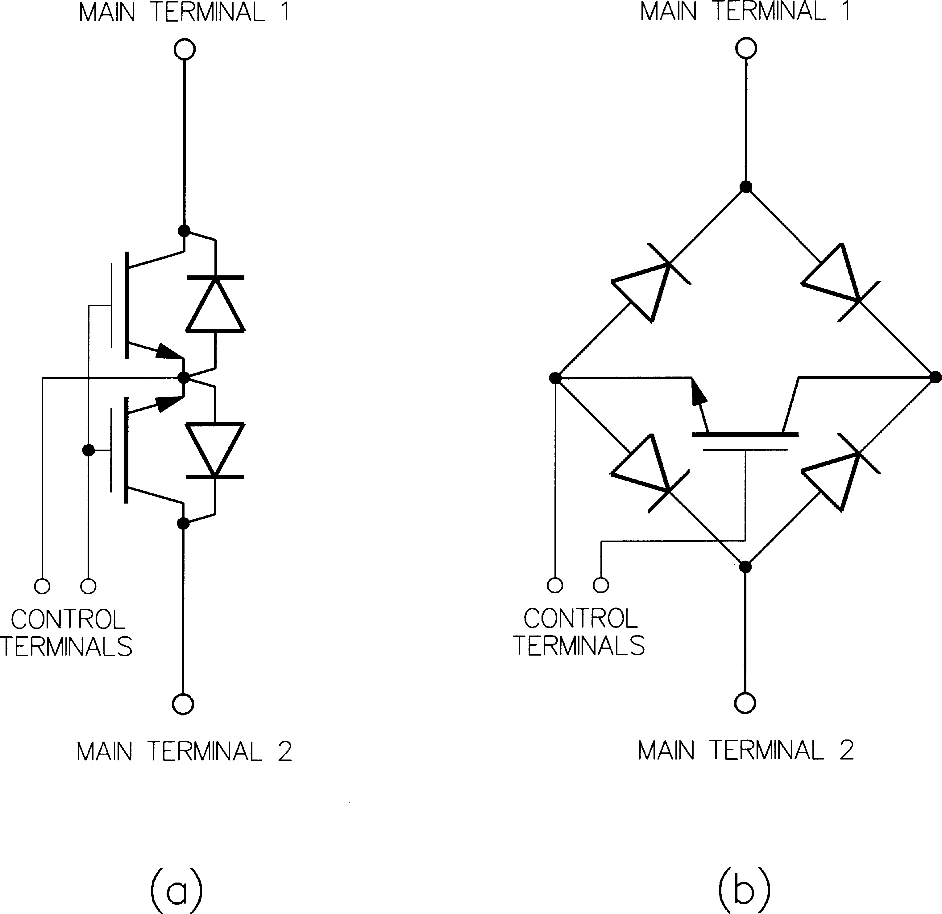

FIGURE 1.30

Fully controlled bidirectional power switch assemblies: (a) two transistors and two diodes, (b) one transistor and four diodes.

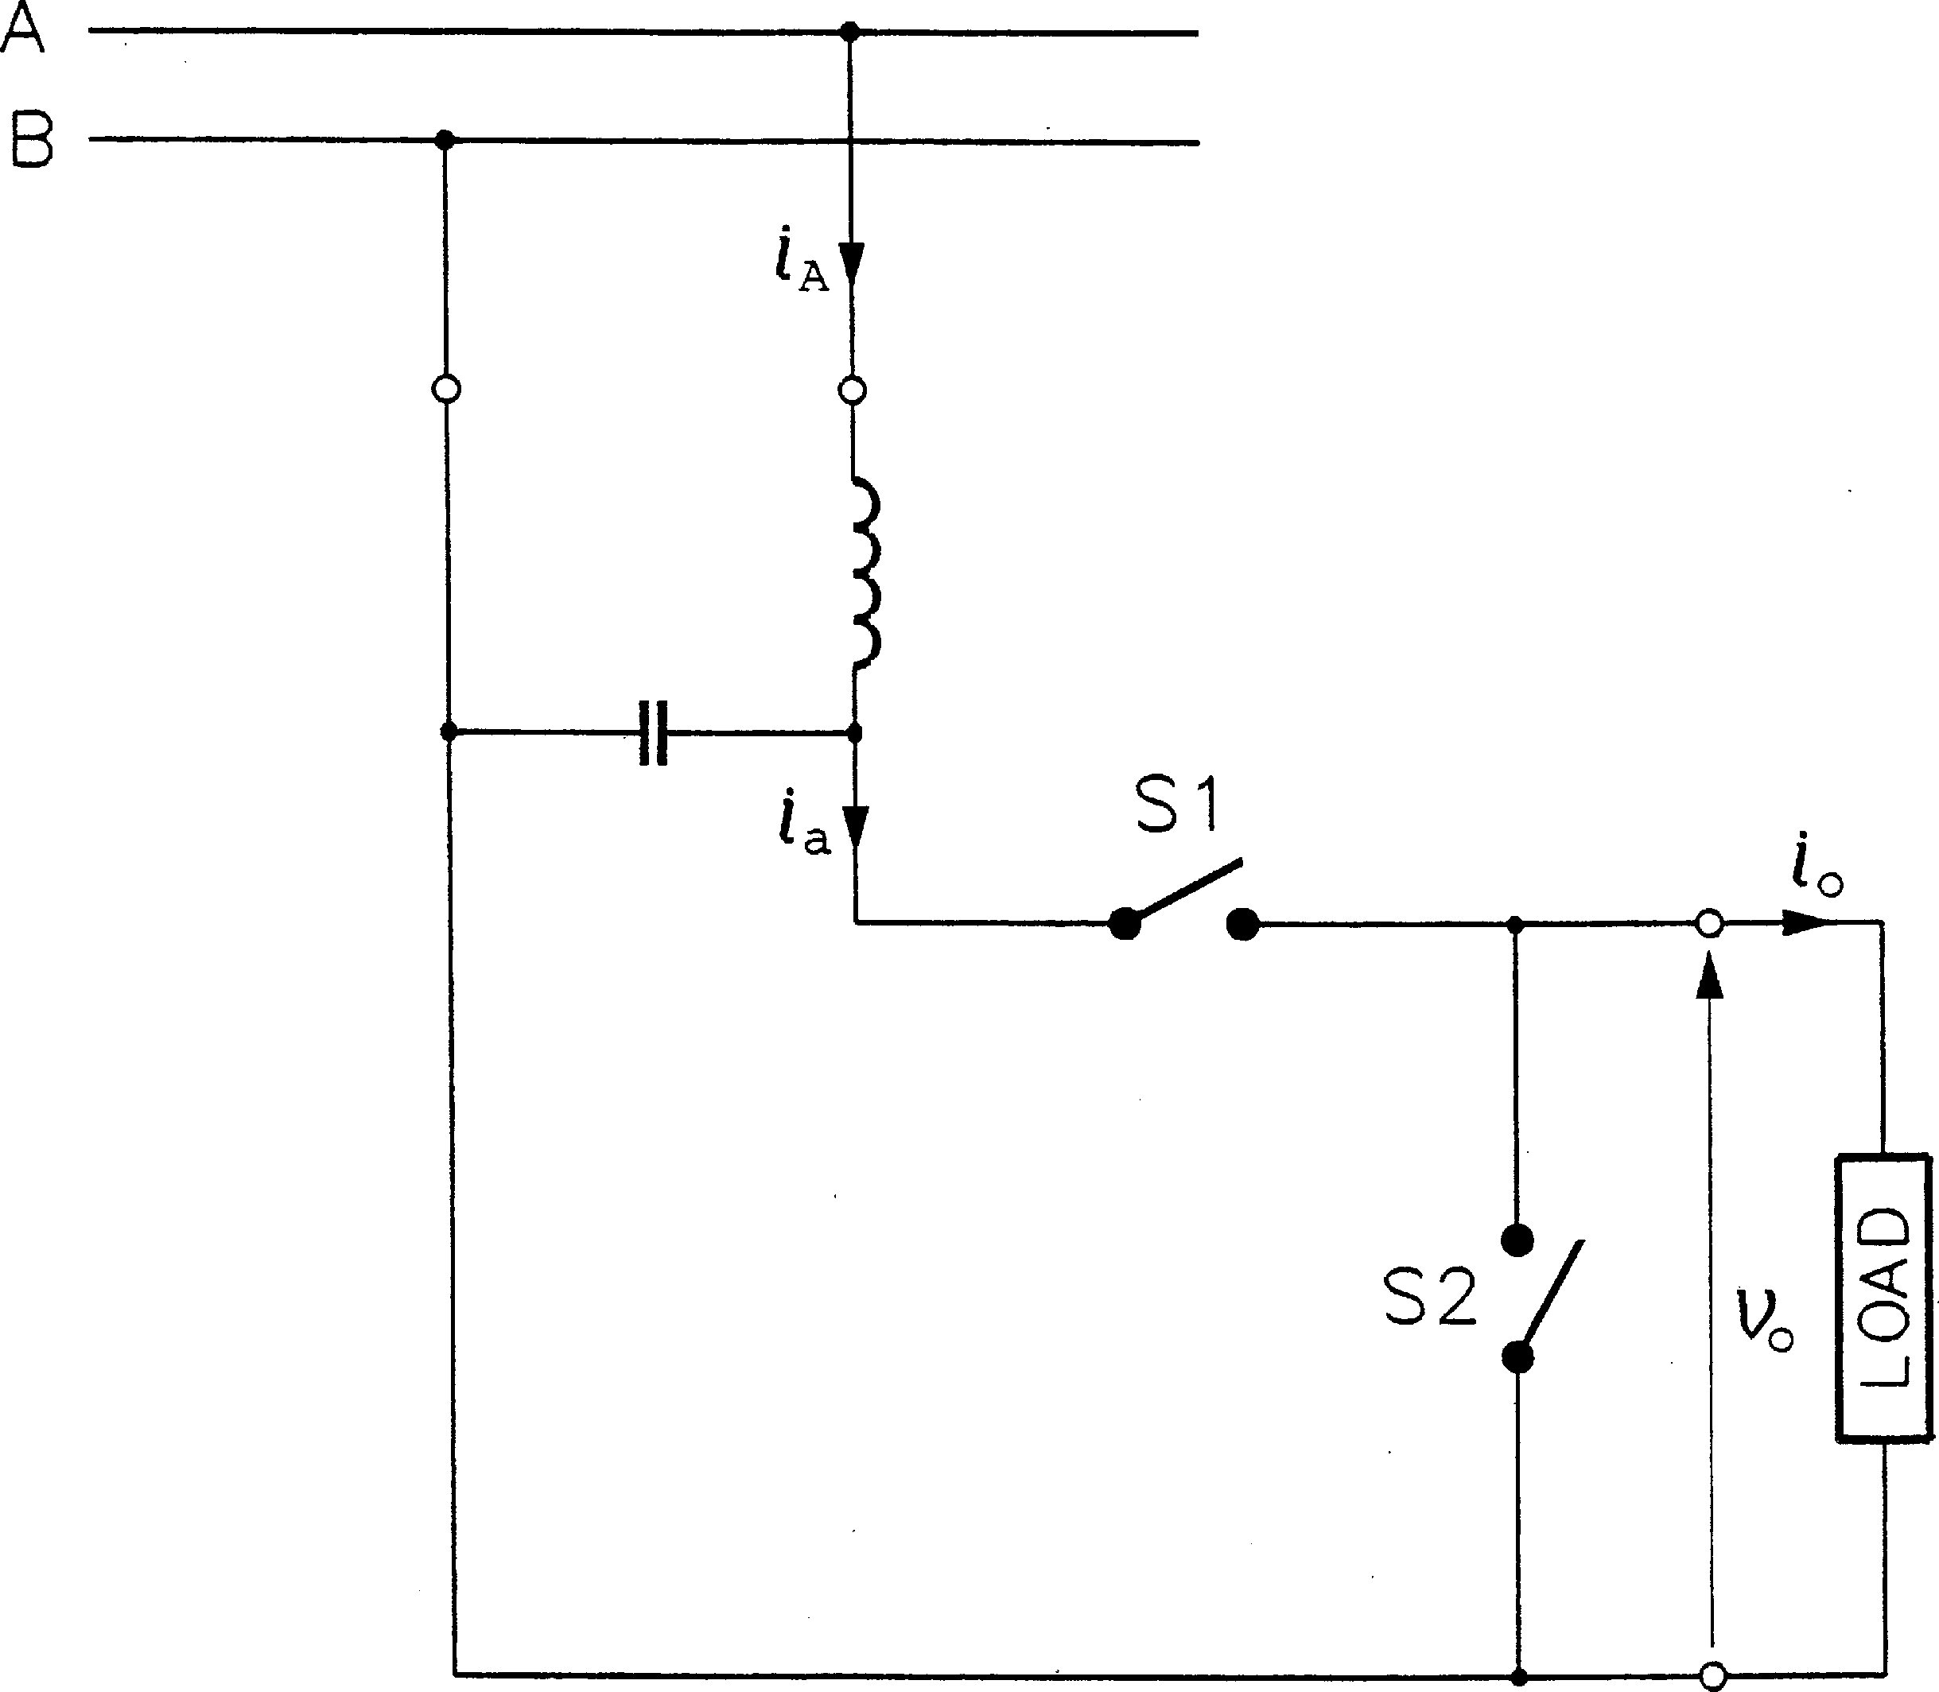

FIGURE 1.31

Single-phase ac chopper.

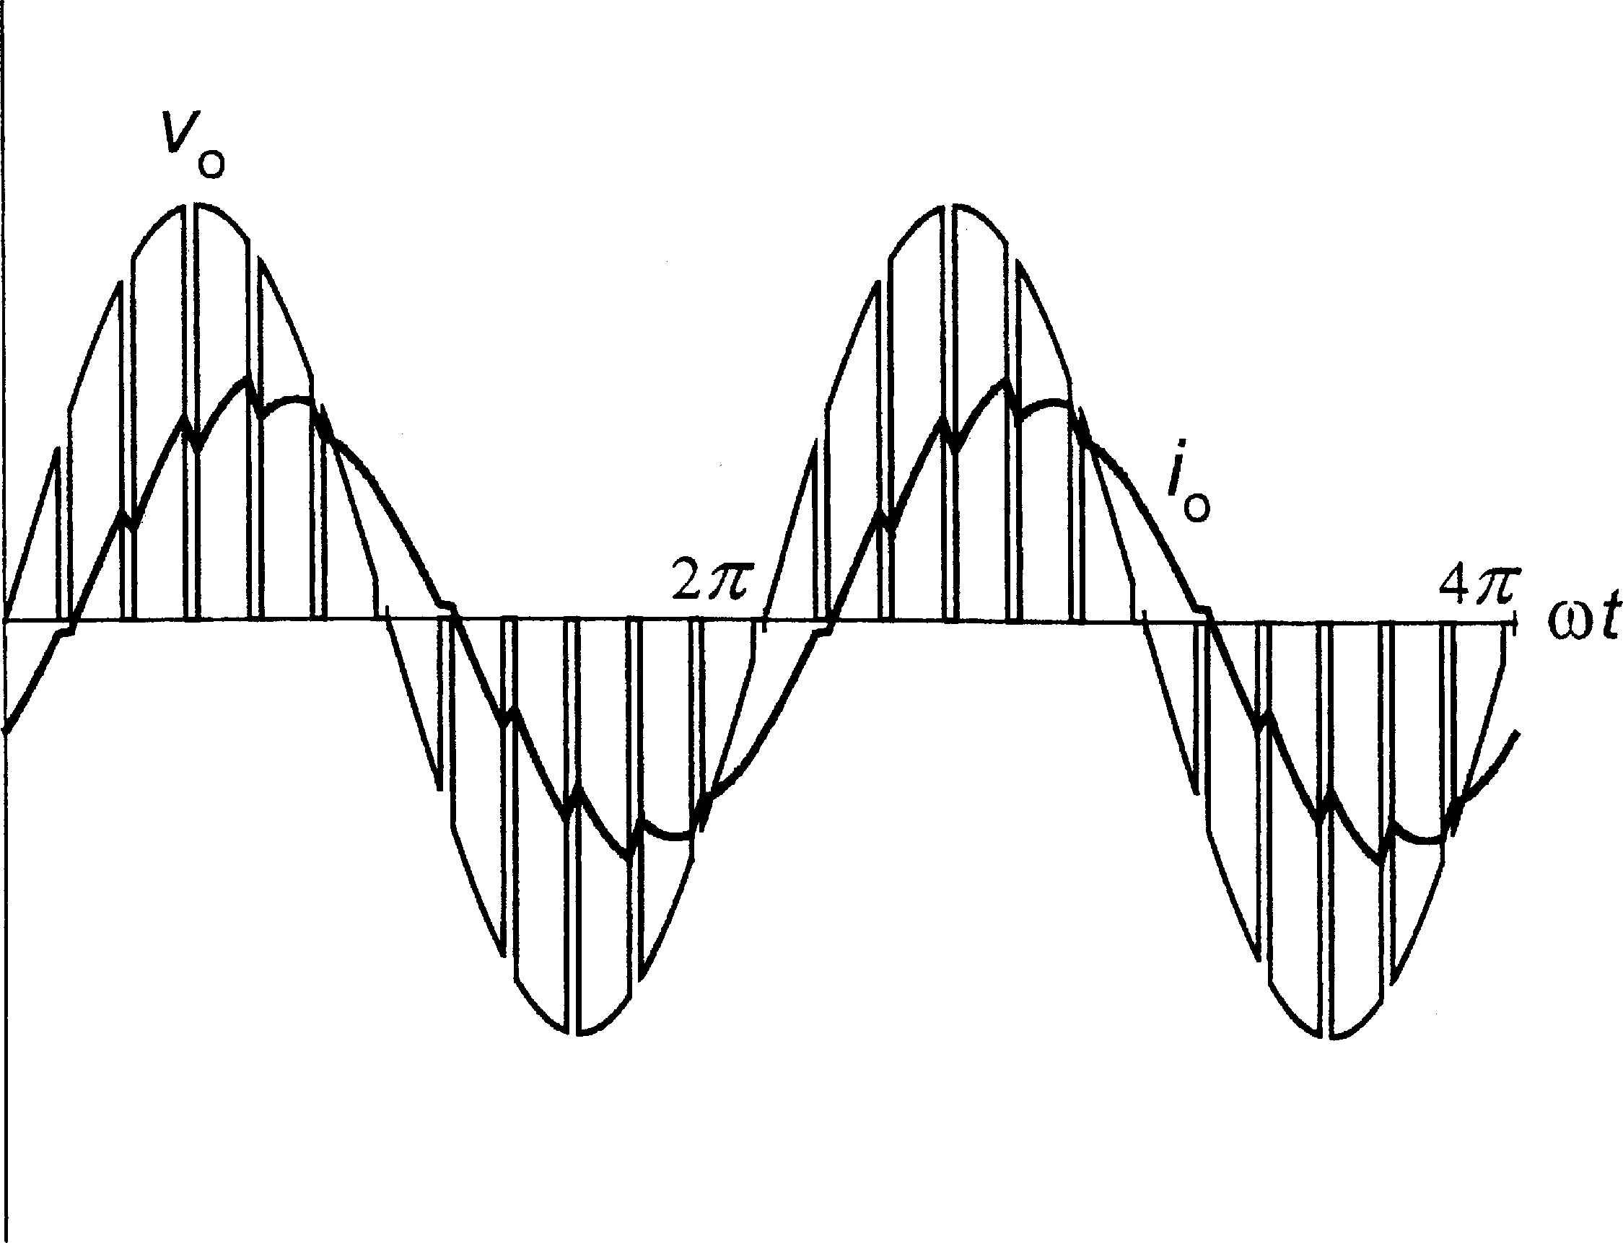

FIGURE 1.32

Output voltage and current waveforms in an ac chopper.

cycloconverters are invariably high-power converters, typically used in adjustable-speed synchronous motor drives requiring sustained low-speed operation.

The matrix converter, shown in Fig. 1.35 in the three-phase to three-phase version, constitutes a network of bidirectional power switches, such as those in Fig. 1.30, connected between each of the input terminals and each of the output terminals. In this respect, the matrix converter

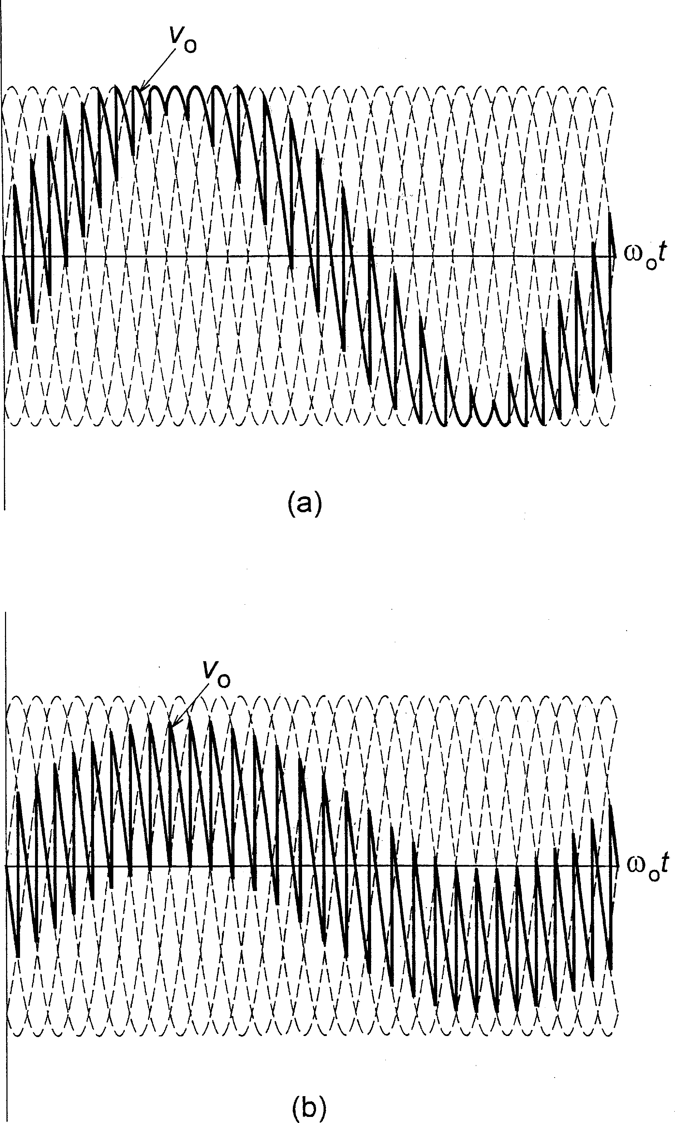

FIGURE 1.33

Waveforms of output voltage in a six-pulse cycloconverter: (a) M ¼ 1, (b) M ¼ 0:5 (oo=o ¼ 0:2).

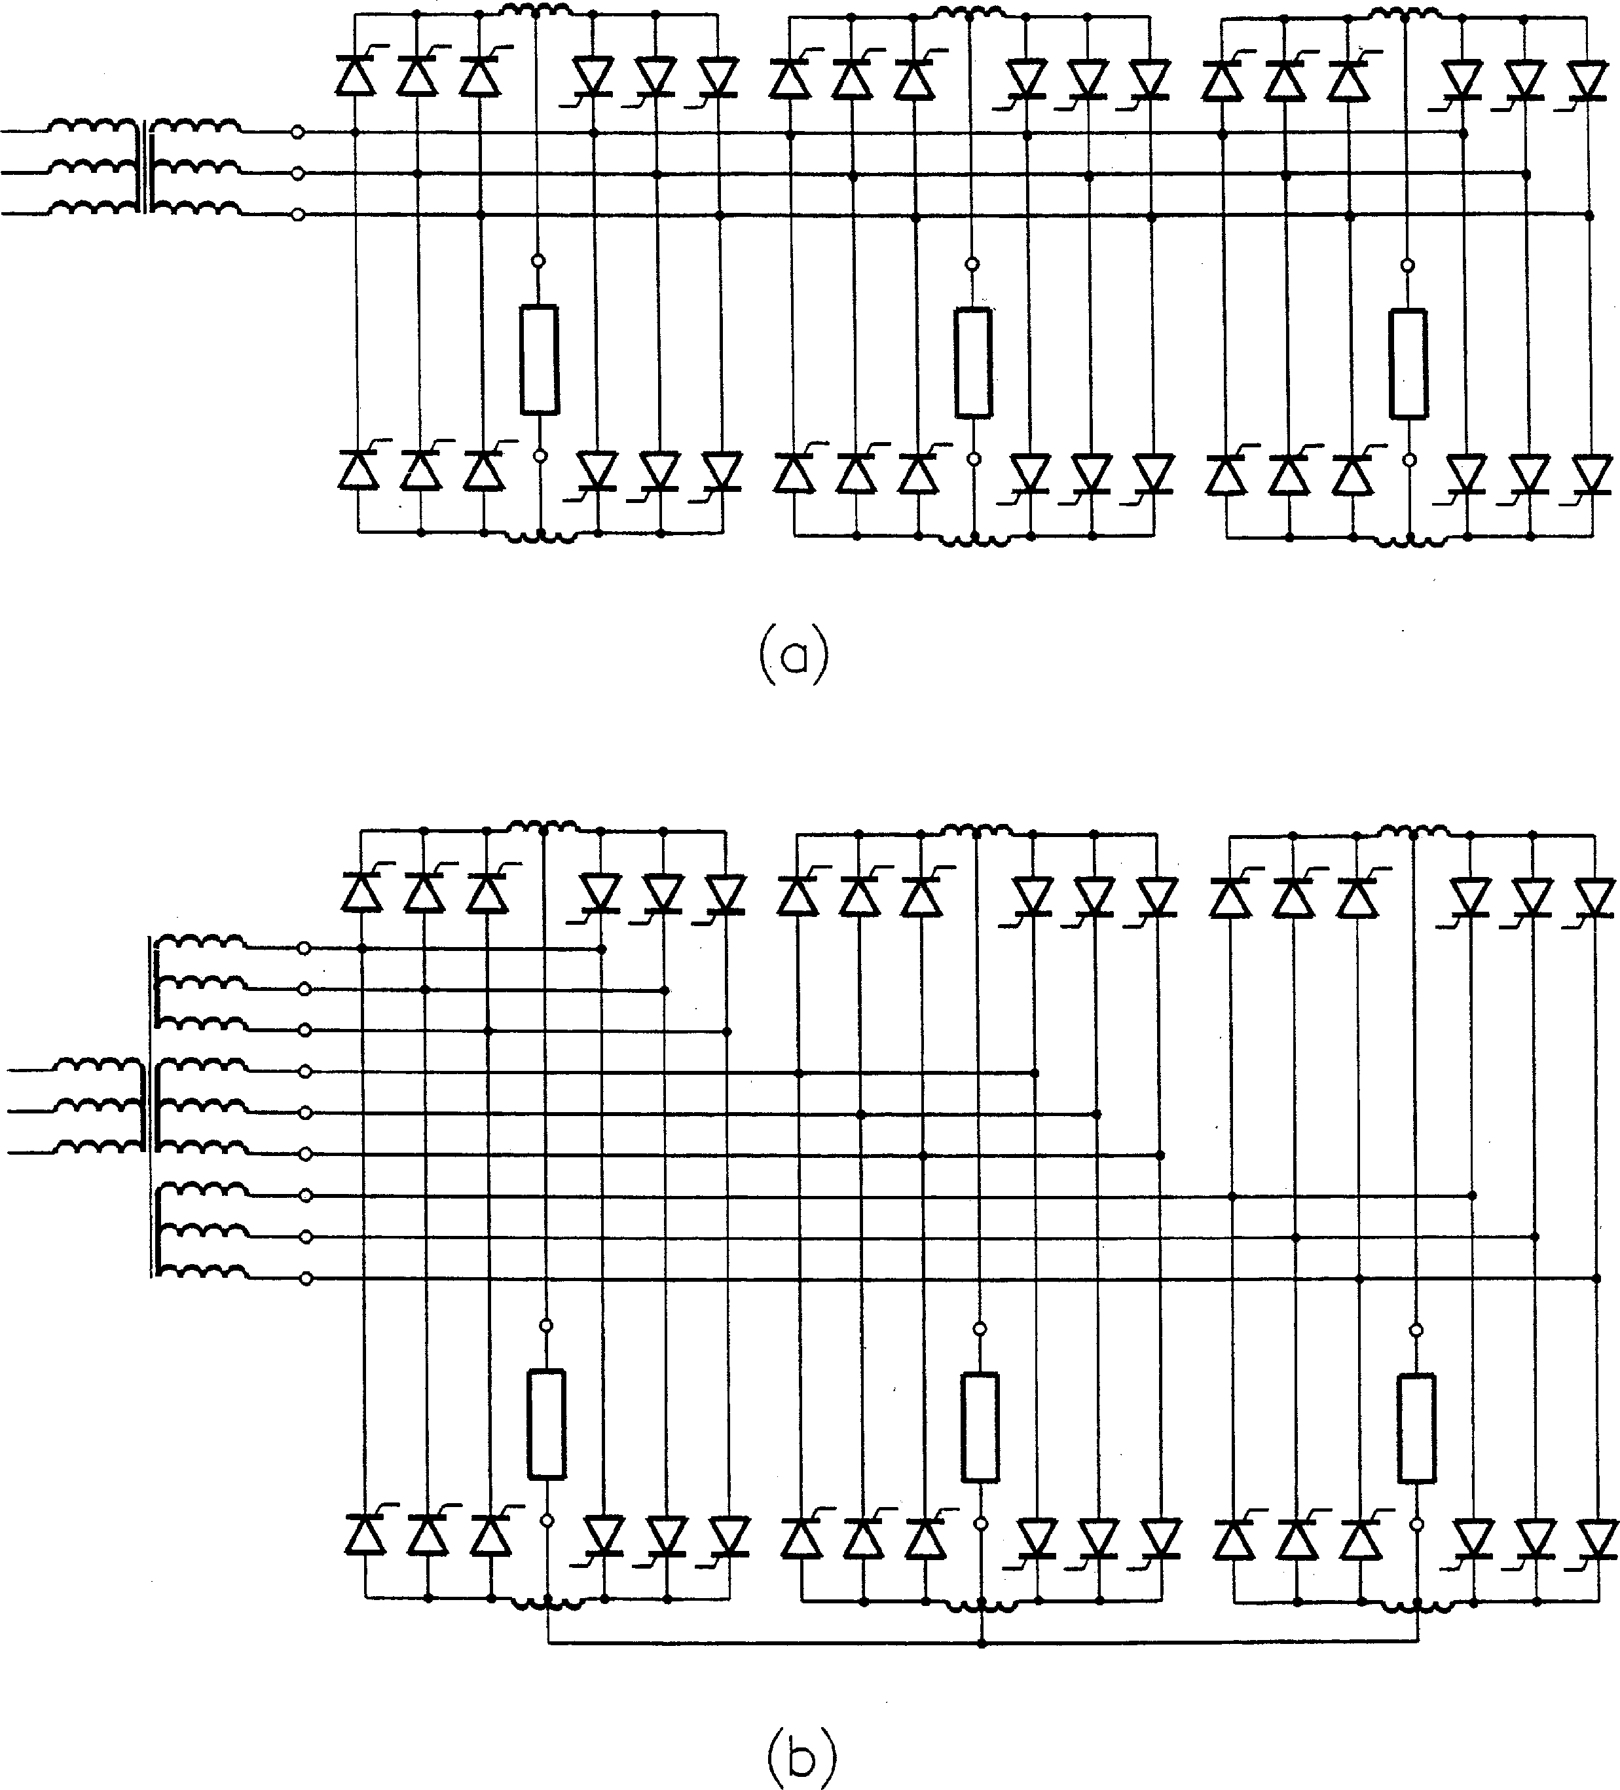

FIGURE 1.34

Three-phase six-pulse cycloconverters: (a) with isolated phase loads, (b) with interconnected phase loads.

constitutes an extension of the generic power converter in Fig. 1.1. The voltage of any input terminal can be made to appear at any output terminal (or terminals), while the current in any phase of the load can be drawn from any phase (or phases) of the supply line. An input LC filter is employed to screen the supply system from harmonic currents generated by the converter, which operates in the PWM mode. The load inductance assures continuity of the output currents. Although, with the 9 switches, the matrix converter can theoretically have 512 states, only 27 states are permitted. Specifically, at any time, one and only one switch in each row must be closed. Otherwise, the input terminals would be shorted or the output currents would be interrupted.

The voltages, va; vb, and vc, at the output terminals are given by

2 v 3

a

2

xAa

xBa

xCa

32 v 3

A

4 vb 5 ¼ 4 xAb xBb xCb 54 vB 5 ð1:12Þ

vc xAc xBc xCc vC

where xAa through xCc denote switching functions of switches SAa through SCc, and vA; vB, and vC are the voltages at the input terminals. In turn, the line-to-neutral output voltages, van; vbn, and vcn, can be expressed in terms of va; vb, and vc as

2 v 3

2 32 3

2 —1 —1 v

1

an

4 vbn 5 ¼ 3 4

v

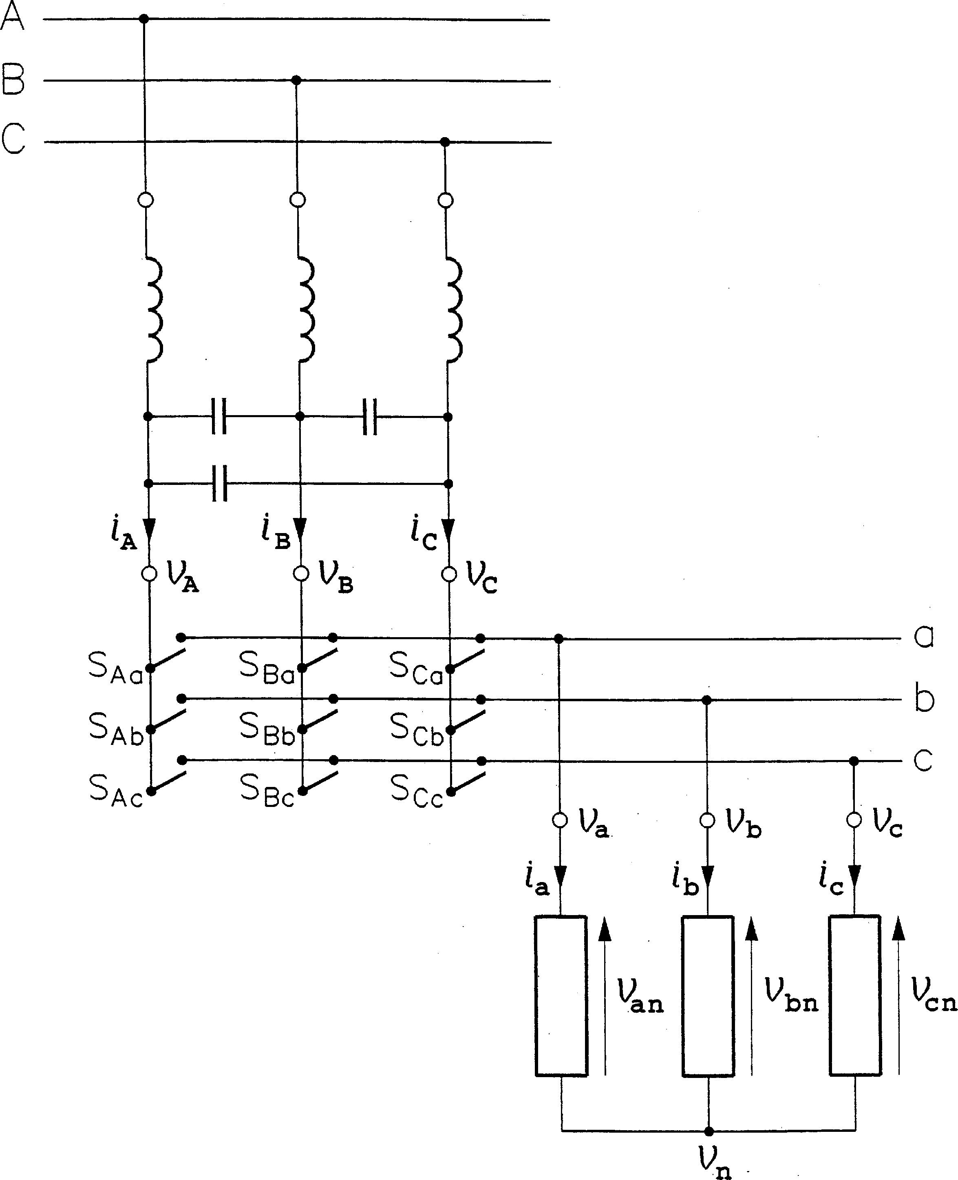

FIGURE 1.35

Three-phase to three-phase matrix converter.

The input currents, iA; iB, and iC, are related to the output currents, ia; ib, and ic, as

2 3 2

iA

32 3

xAa xAb xAc ia

4 iB 5 ¼ 4 xBa xBb xBc 54 ib 5: ð1:14Þ

iC xCa xCb xCc ic

Fundamentals of both the output voltages and input currents can successfully be controlled by employing a specific, appropriately timed sequence of the switching functions. As a result of such control, the fundamental output voltages acquire the desired frequency and amplitude, while the low-distortion input currents have the required phase shift (usually zero) with respect to the corresponding input voltages.

Example waveforms of the output voltage and current are shown in Fig. 1.36. For reference, waveforms of the line-to-line input voltages are shown, too. The output frequency, oo, in Fig. 1.36a is 2.8 times higher than the input frequency, o, while the oo=o ratio in Fig. 1.36b is 0.7. Respective magnitude control ratios, M, are 0.8 and 0.4.

Apart from the conceptual simplicity and elegance, matrix converters have not yet found

iﬃdﬃ espread application in practice. Two major reasons are the low voltage gain, limited to 3=2 ≈ 0:866, and unavailability of fully controlled bidirectional semiconductor switches.

DC TO DC CONVERTERS

Dc to dc converters, called choppers, are supplied from a dc voltage source, typically a diode rectifier and a dc link, as shown in Fig. 1.37. The dc link consists of a large capacitor connected

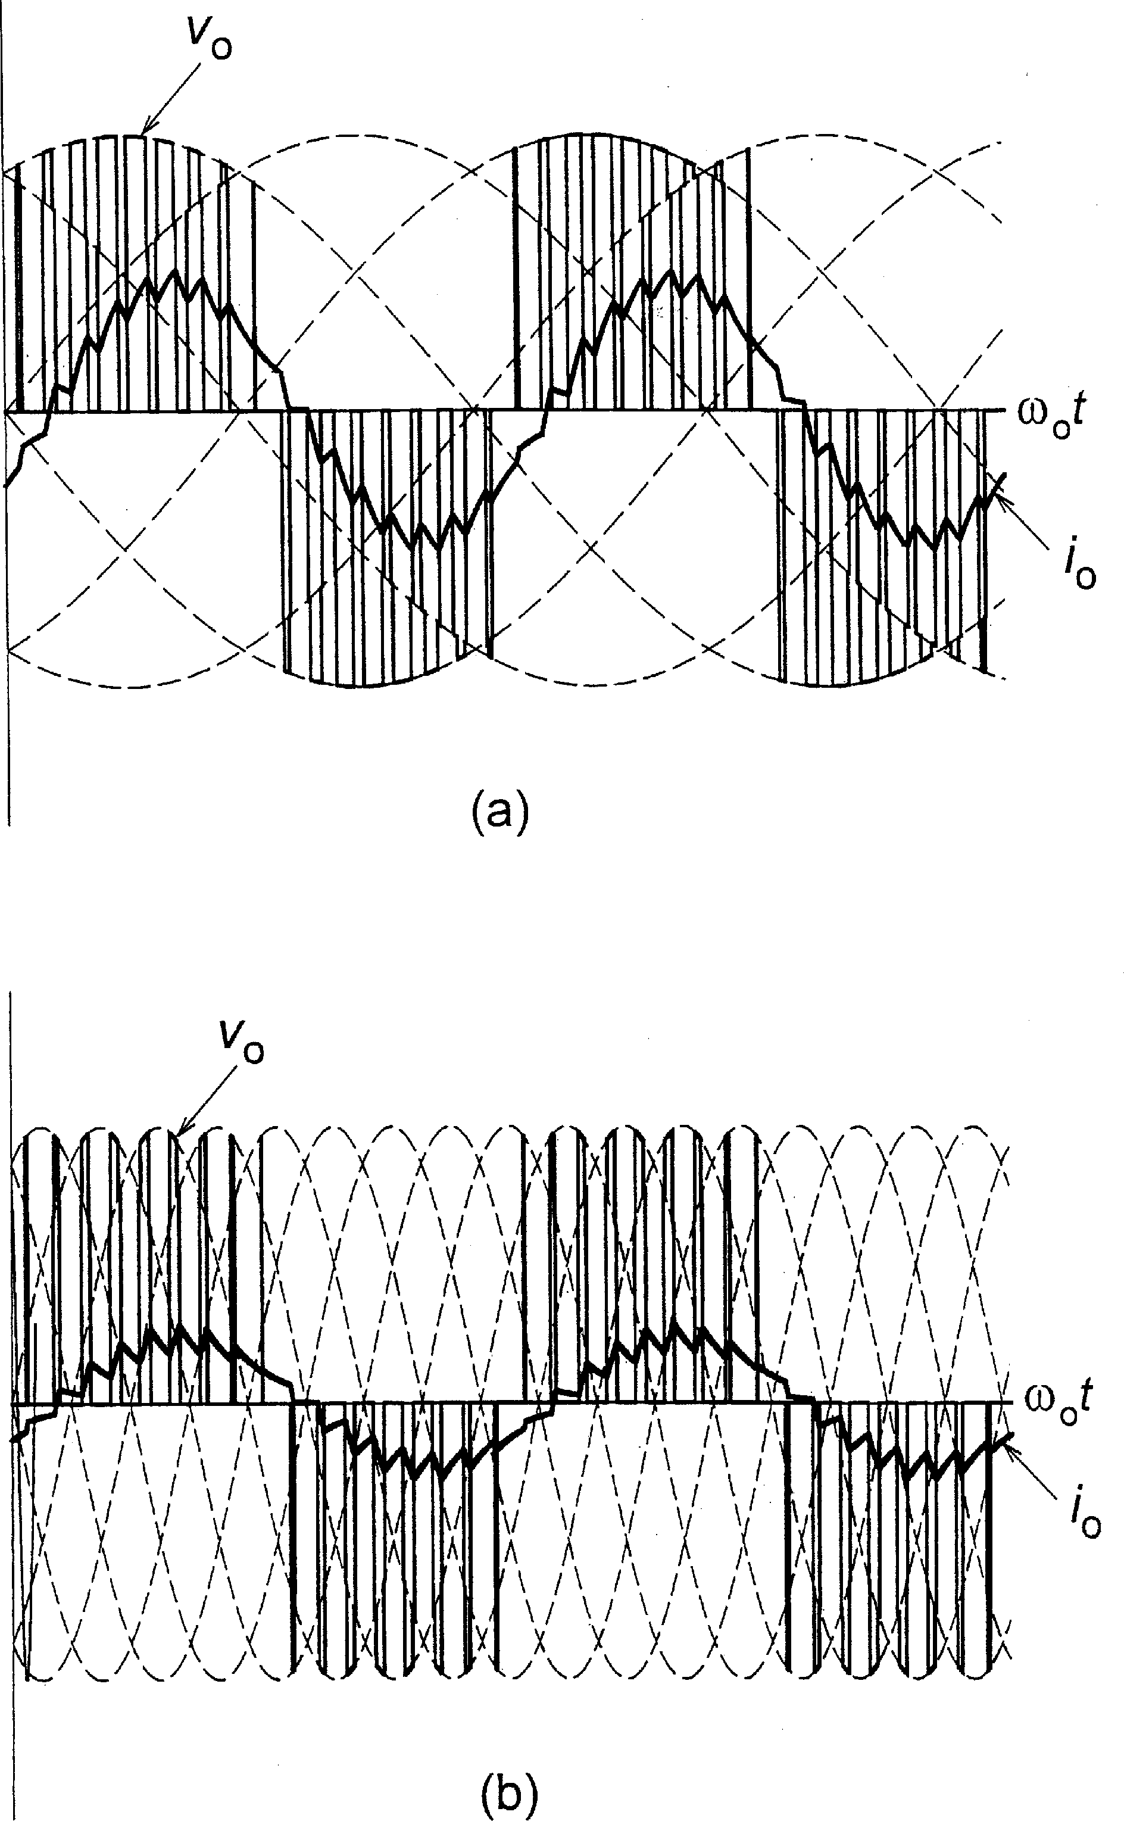

FIGURE 1.36

Output voltage and current waveforms in a matrix converter: (a) oo=o ¼ 2:8; M ¼ 0:8; (b)

oo=o ¼ 0:7; M ¼ 0:4.

across the input terminals of the chopper and, often but not necessarily, a series inductance. The capacitor smooths the dc voltage produced by the rectifier and serves as a source of the high- frequency ripple current drawn by the chopper. The inductor provides an extra screen for the supply power system against the high-frequency currents. All choppers are pulse width modulated, the phase control being infeasible with both the input and output voltages of the dc type.

Most choppers are of the step-down (buck) type, that is, the average output voltage, Vo, is always lower than the input voltage, Vi. The first-quadrant chopper, based on a single fully

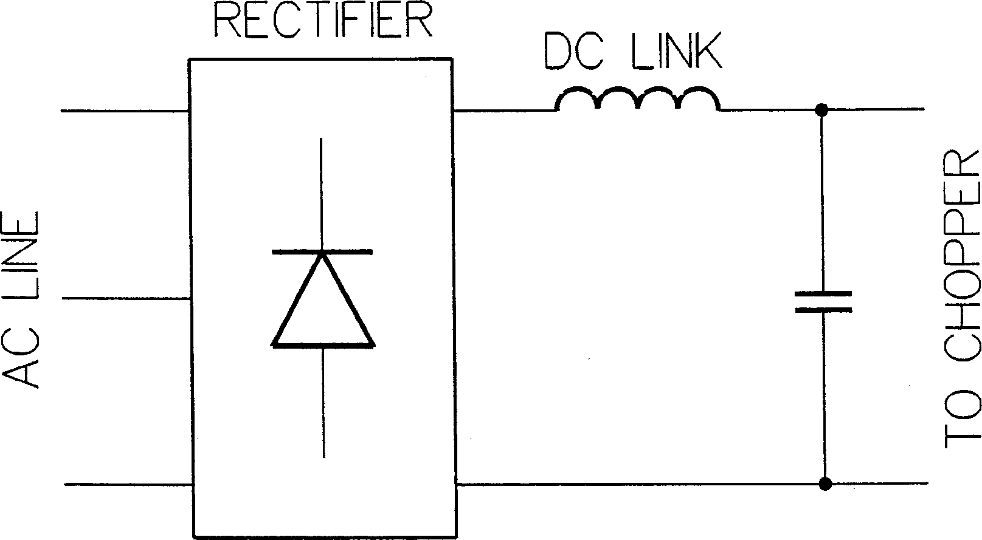

FIGURE 1.37

Dc voltage source for choppers.

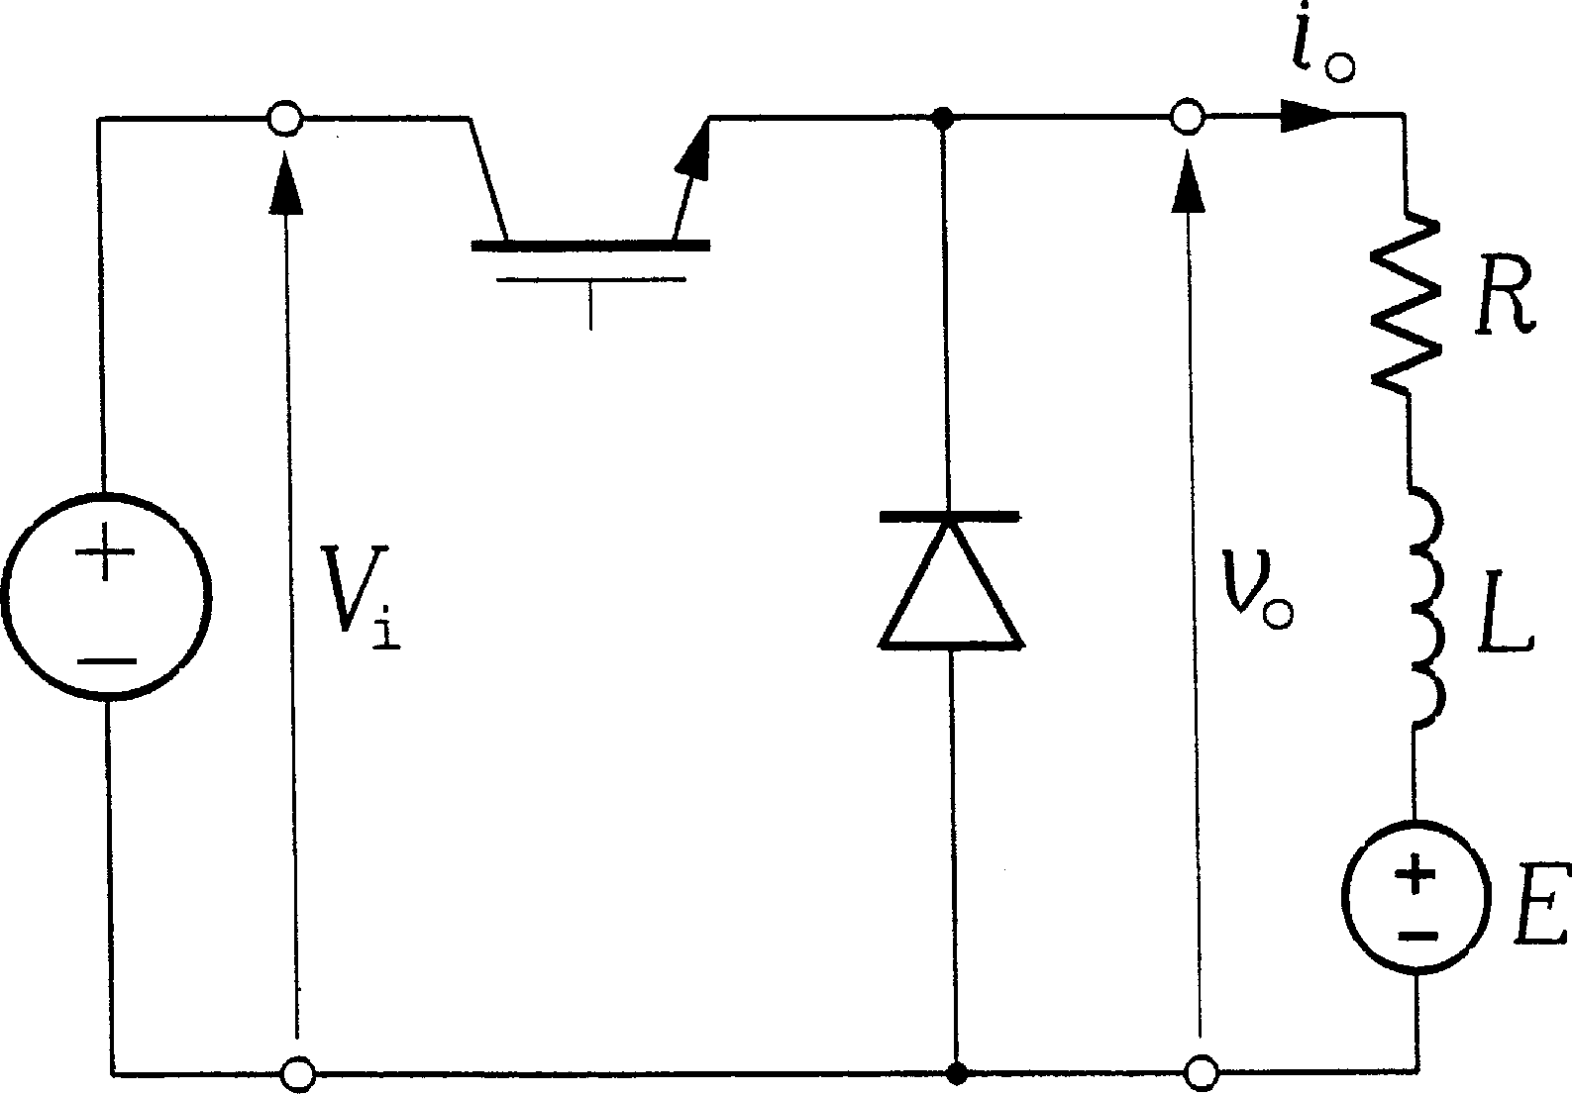

FIGURE 1.38

First-quadrant chopper.

controlled switch and a freewheeling diode, is shown in Fig. 1.38. Both the output voltage, vo, and current, io, can only be positive. The average output voltage is given by

Vo ¼ DVi ð1:15Þ

where D denotes the duty ratio of the switch. The magnitude control ratio, M, is defined here as Vo=Vi and it equals D. Example waveforms of vo and io are shown in Fig. 1.39, with M changing from 0.5 to 0.75. As in all PWM converters, the output voltage is pulsed, but the output current is continuous thanks to the load inductance. The current ripple is inverse proportional to the switching frequency, fsw. Specifically, the rms value, Io;ac, of the ac component of the output current is given by

Io;ac ¼

jM jð1 — jM jÞ

Vi ð1:16Þ

where L denotes inductance of the load.

pﬃﬃﬃ

2 3Lfsw

The reason for the absolute value, M , of the magnitude control ratio appearing in Eq. (1.16) is that this ratio in choppers can assume both the positive and negative values. In particular, M > 0 indicates operation in the first and third quadrant (see Fig. 1.14), while M < 0 is specific for choppers operating in the second and fourth quadrant. The most versatile dc to dc converter, the four-quadrant chopper shown in Fig. 1.40, can, as its name indicates, operate in all four quadrants.

j j

In the first quadrant, switch S4 is turned on all the time, to provide a path for the output current, io, while switch S1 is chopping with the duty ratio D1. The remaining two switches, S2 and S3, are OFF. In the second quadrant, it is switch S2 that is chopping, with the duty ratio D2,

and all the other switches are OFF. Analogously, in the third quadrant, switch S1 is ON, switch S3 is chopping with the duty ratio D3 and, in the fourth quadrant, switch S4 is chopping with the

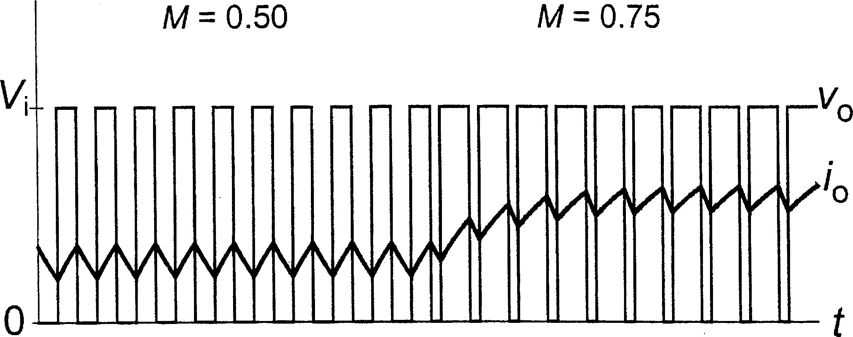

FIGURE 1.39

Example waveform of output voltage and current in a first-quadrant chopper.

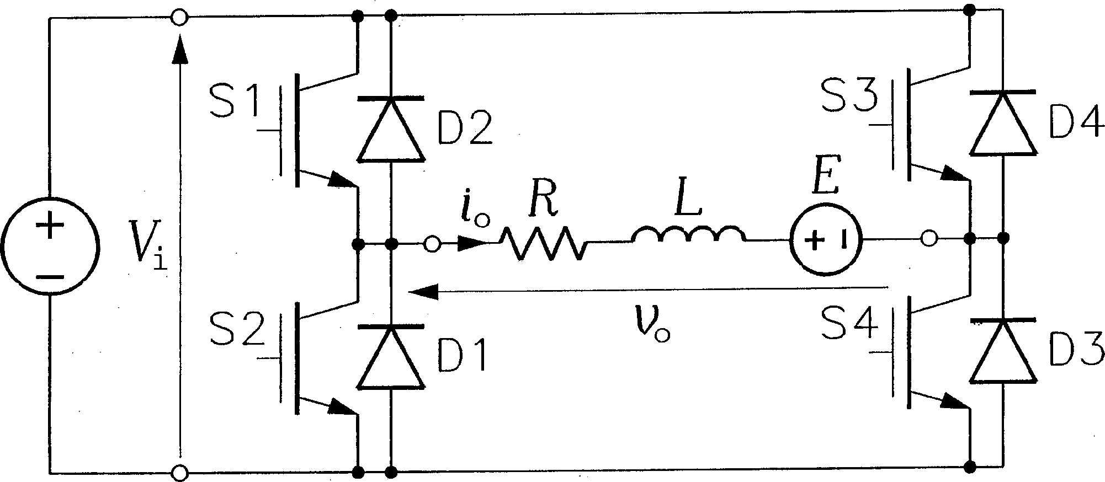

FIGURE 1.40

Four-quadrant chopper.

duty ratio D4. When a chopping switch is OFF, conduction of the output current is taken over by a respective freewheeling diode, for instance, D1 in the first quadrant of operation. The magnitude control ratio, M, is given by

If the chopper operates in Quadrants 2 and 4, the power flows from the load to the source, necessitating presence of an EMF, E, in the load. The EMF must be positive in Quadrants 1 and 2, and negative in Quadrants 3 and 4. For sustained operation of the chopper with a continuous

output current, the magnitude control ratio must be limited in dependence on the ratio E=Vi as illustrated in Fig. 1.41. These limitations, as well as Eq. (1.17), apply to all choppers.

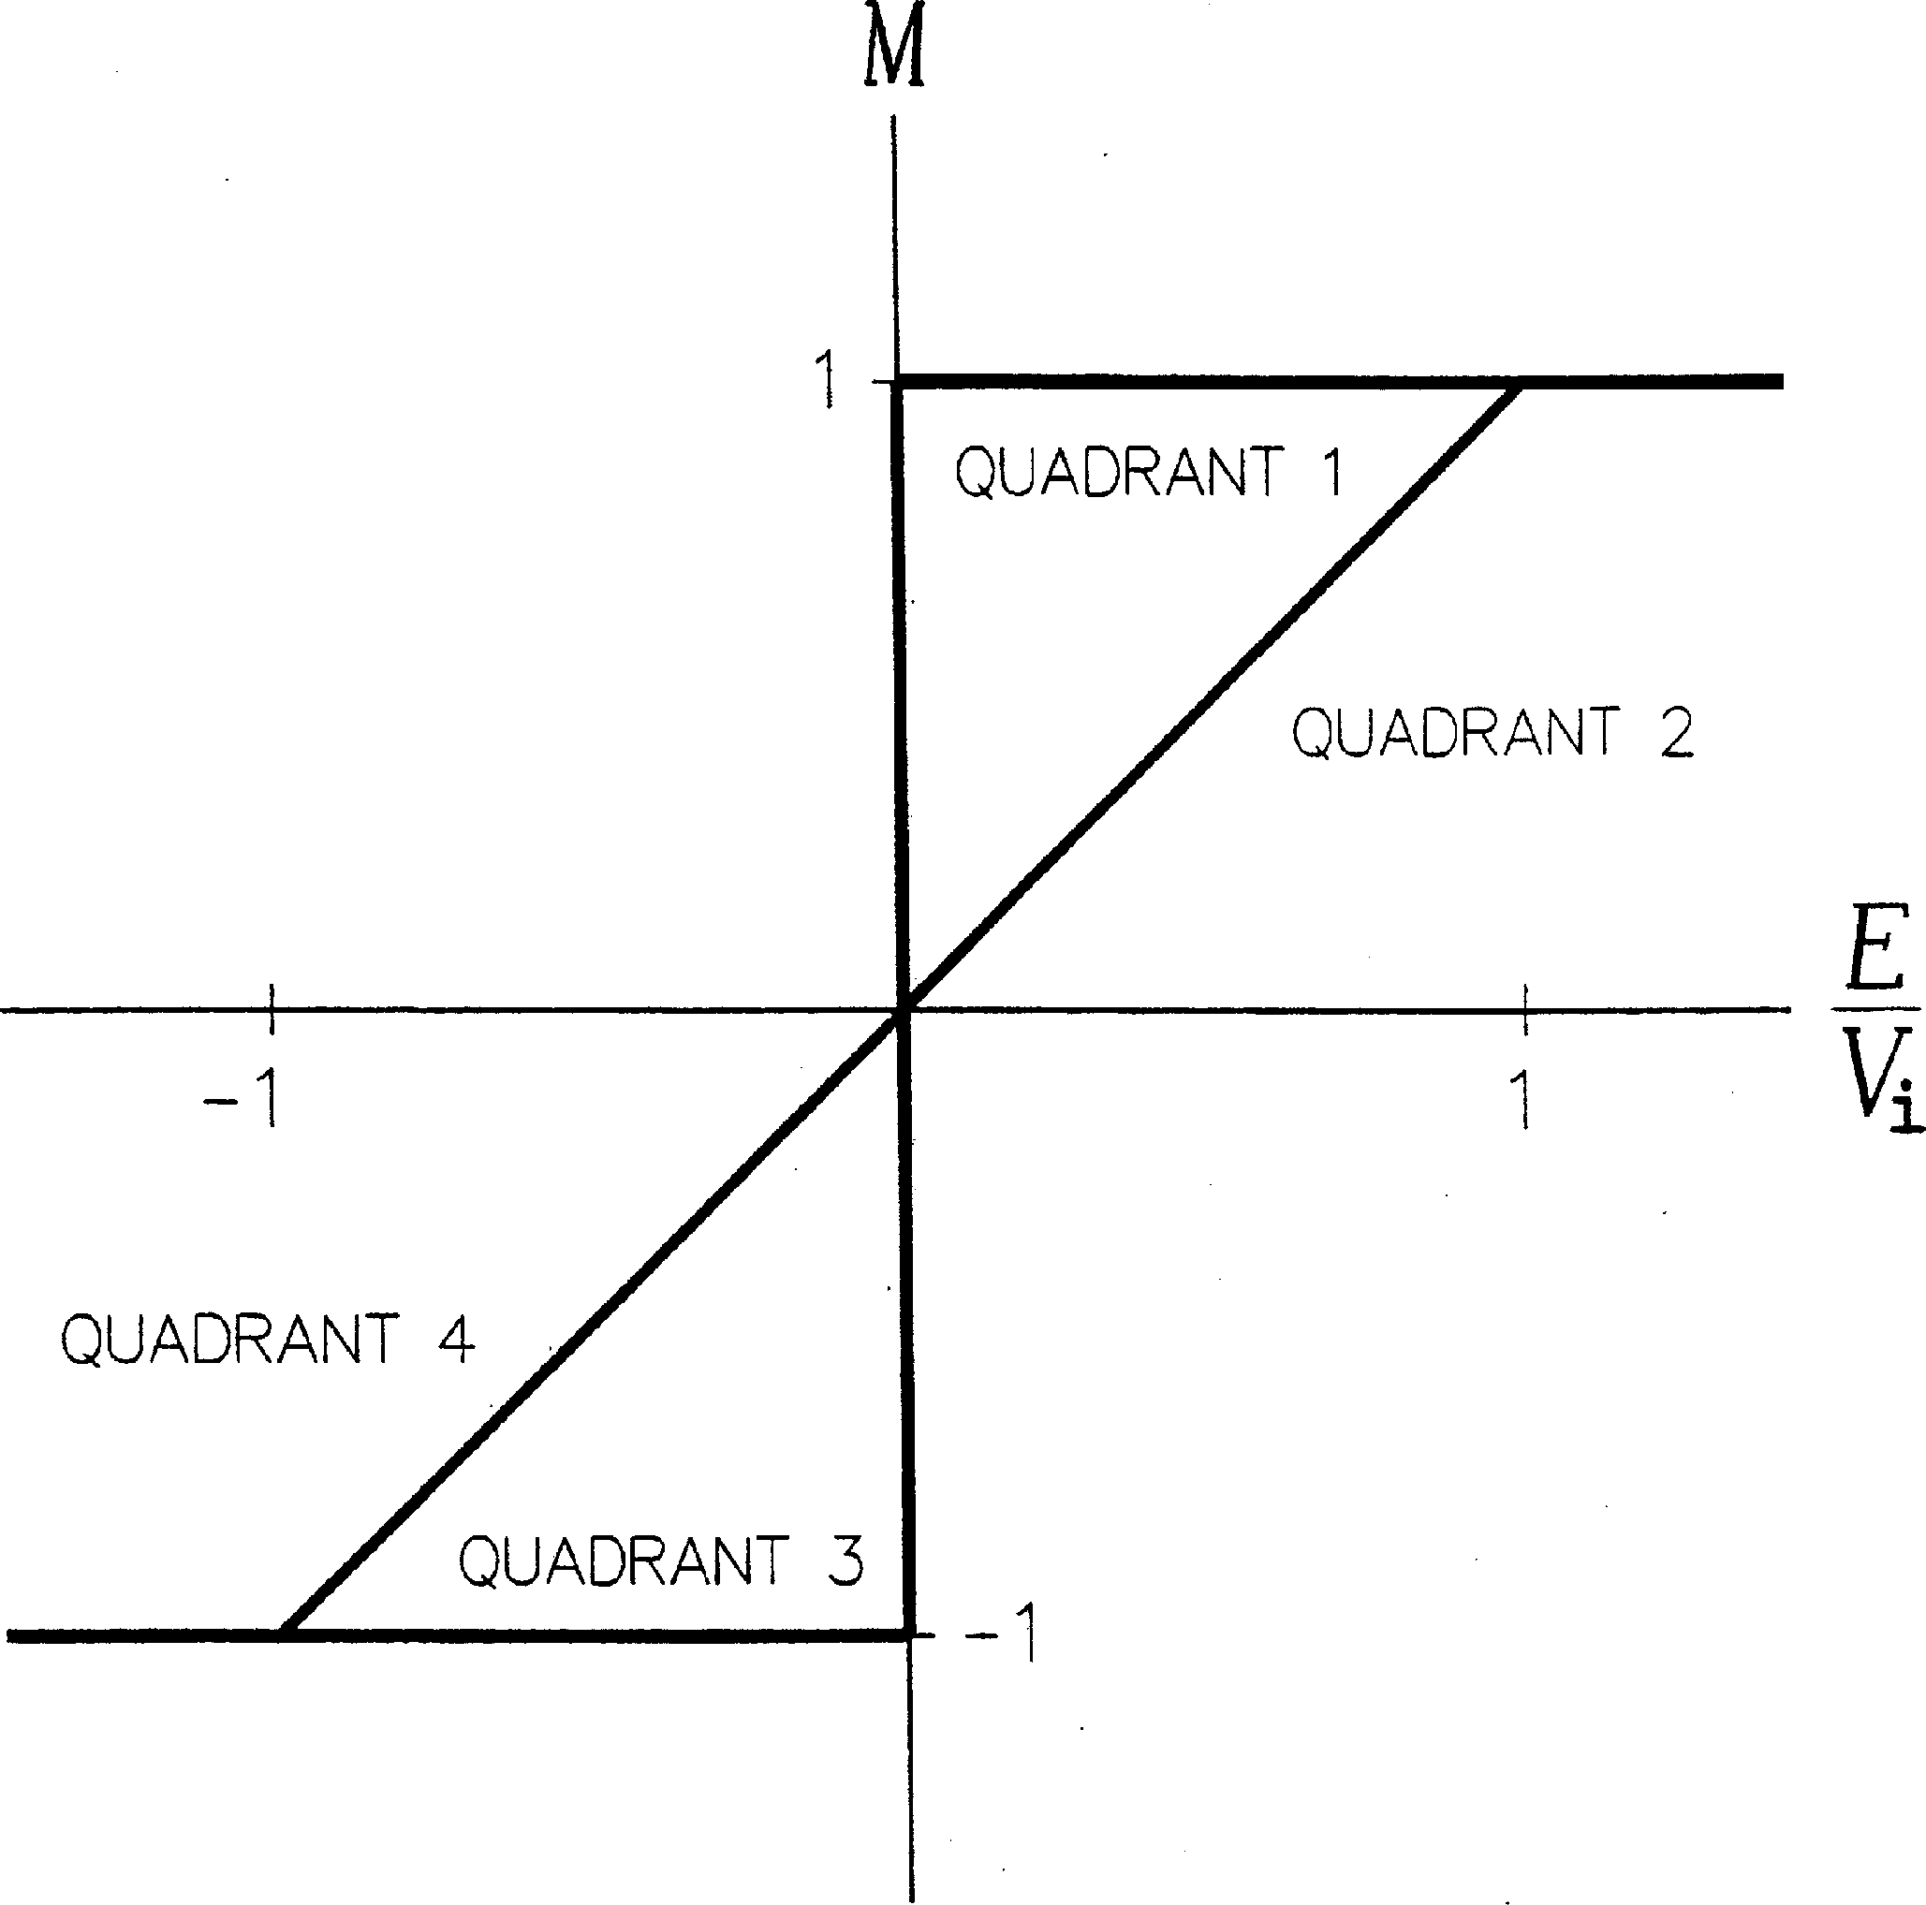Any less-than-four-quadrant chopper can easily be obtained from the four-quadrant topology. Consider, for instance, a two-quadrant chopper, capable of producing an output voltage of both polarities, but with only a positive output current. Clearly, this converter can operate in the first and fourth quadrants. Its circuit diagram, shown in Fig. 1.42, is determined by eliminating switches S2 and S3 and their companion diodes, D2 and D3, from the four-quadrant chopper circuit in Fig. 1.40.

FIGURE 1.41

Allowable ranges of the magnitude control ratio in a four-quadrant chopper.

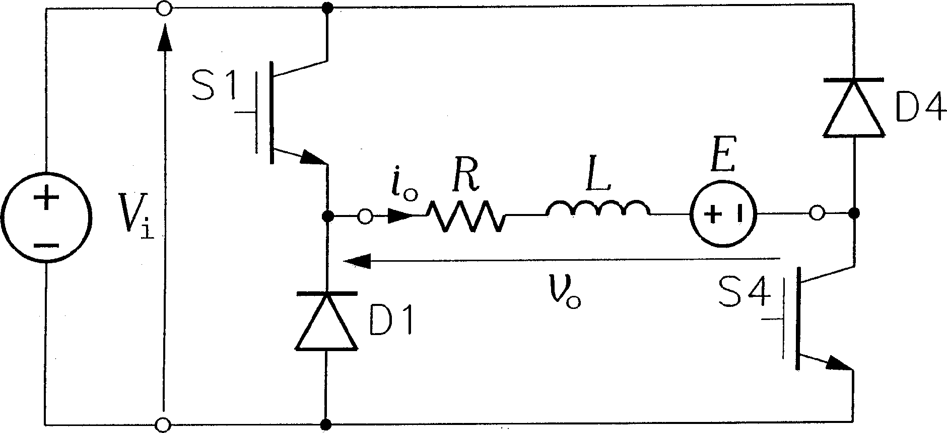

FIGURE 1.42

First-and-fourth-quadrant chopper.

A step-up (boost) chopper, shown in Fig. 1.43, produces a pulsed output voltage, whose

amplitude, Vo;p, is higher than the input voltage. If a sufficiently large capacitor is connected across the output terminals, the output voltage becomes continuous, with Vo ≈ Vo;p > Vi. When switch S is turned on, the input inductor, Lc, is charged with electromagnetic energy, which is then released into the load by turning the switch off. The magnitude control ratio, M, defined as

Vo;p=Vi, in an ideal (lossless) step-up chopper is given by

1

M ¼ 1 — D ð1:18Þ

where D denotes the duty ratio of the switch. In real choppers, the value of M saturates at a certain level, usually not exceeding 10 and dependent mostly on the resistance of the input inductor. Example waveforms of the output voltage and current in a step-up chopper without the output capacitor are shown in Fig. 1.44.

DC TO AC CONVERTERS

Dc to ac converters are called inverters and, depending on the type of the supply source and the related topology of the power circuit, they are classified as voltage-source inverters (VSIs) and current-source inverters (CSIs). The simplest, single-phase, half-bridge, VSI is shown in Fig.

1.45. The switches may not be ON simultaneously, because they would short the supply source. There is no danger in turning both switches off, but the output voltage, vo, would then depend on the conducting diode, that is, it could not be determined without some current sensing arrangement. Therefore, only two states of the inverter are allowed. Consequently, a single switching function, a, can be assigned to the inverter. Defining it as

if SA ¼ ON and SA0 ¼ OFF

*a* ¼

if SA ¼ OFF and SA0 ¼ ON;

ð1:19Þ

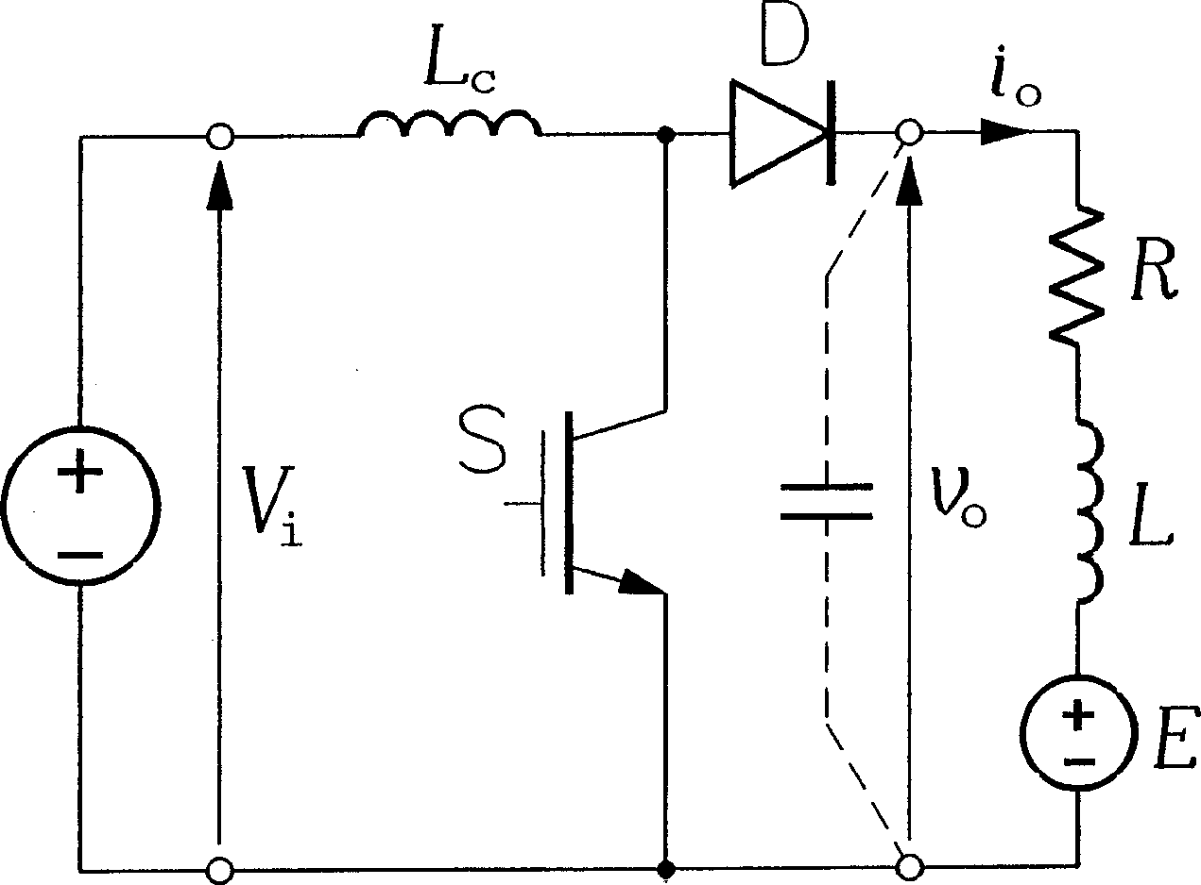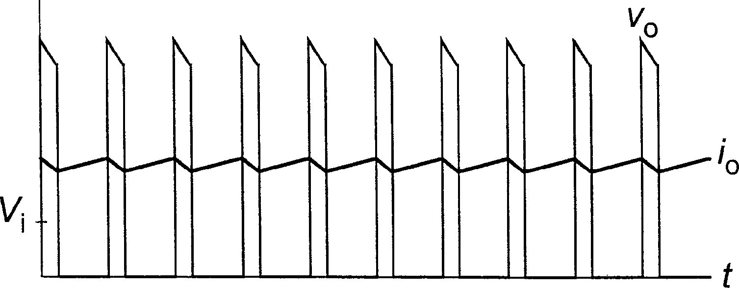

FIGURE 1.43